CSE644 LAB2

Yishi Lu

2/13/2018

In this lab, I use three machines. The first one is SEEDUbuntu with IP address 10.0.2.4 (VM A), the second one is SEEDUbuntu Clone with IP address 10.0.2.5 (VMB), the third one is SEEDUbuntu Clone2 with IP address 10.0.2.6 (VM C).

**Task1**

1. Prevent A doing telnet to Machine B

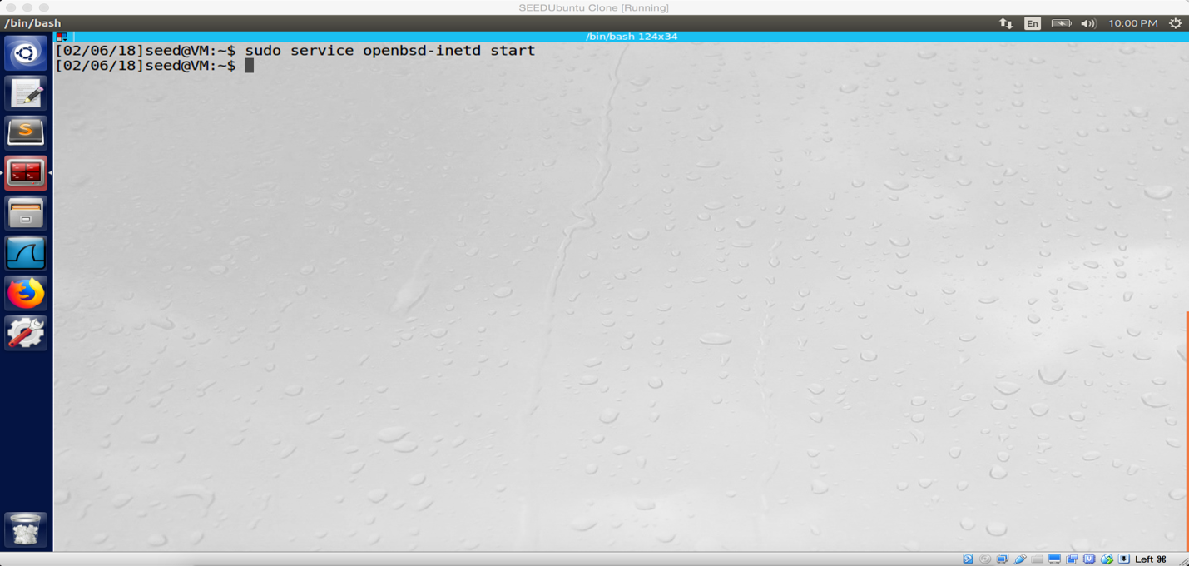

screenshot.1 Start telnet server on VM B

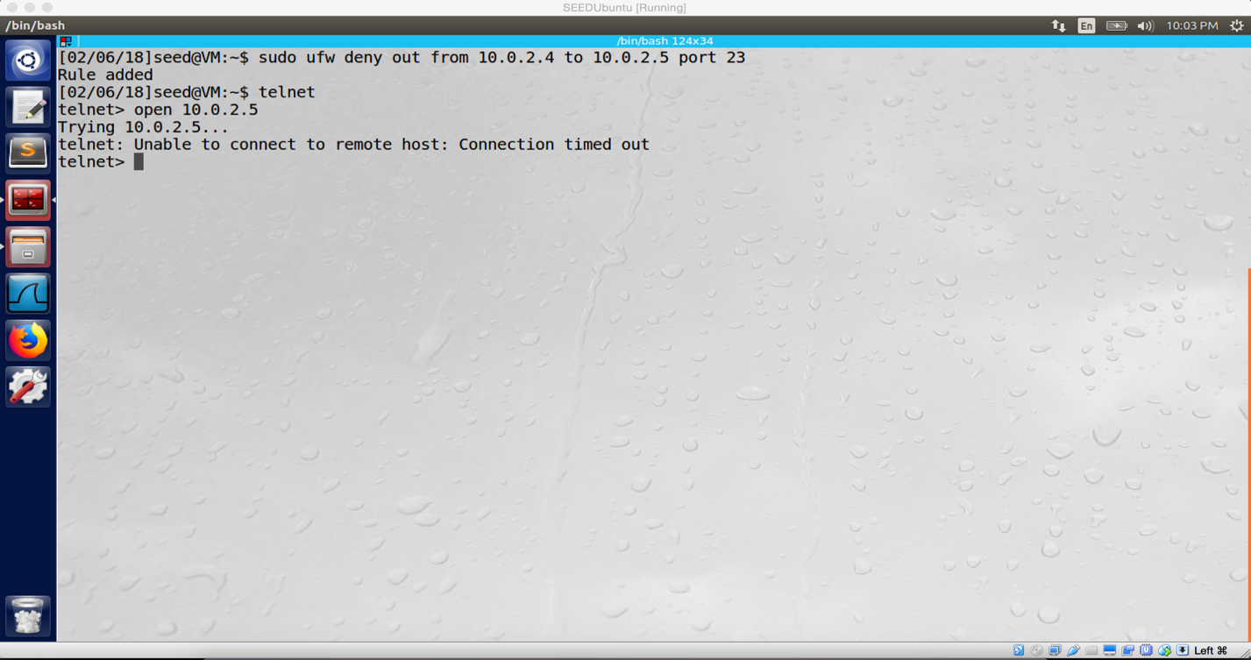

screenshot.2 On VM A. Add rule to prevent VM A doing telnet to VM2 successfully

1. Prevent B from doing telnet to Machine A.

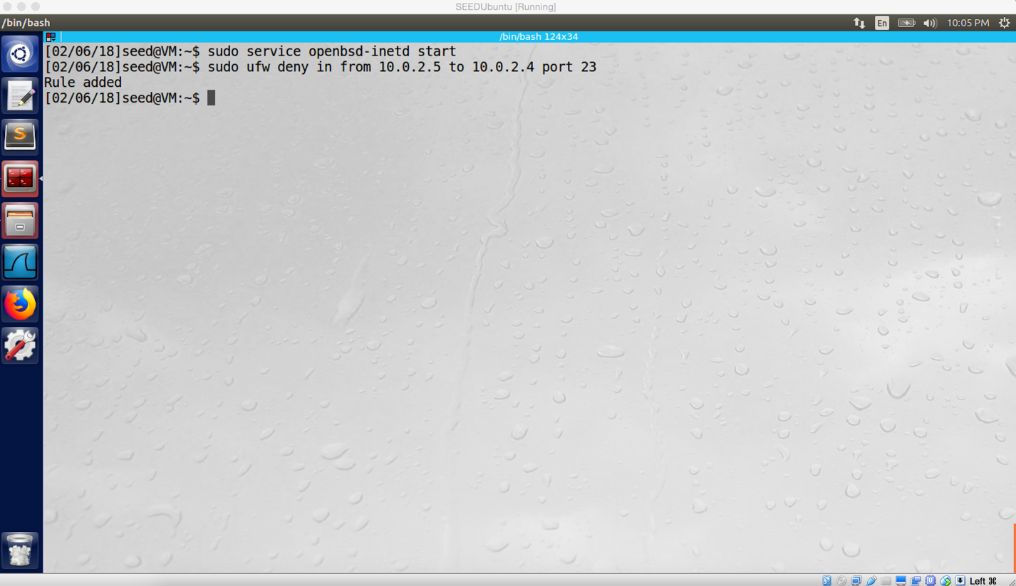

screenshot.3 On VM A. Start telnet sever, and I add rule to prevent VM B doing telnet to VM A.

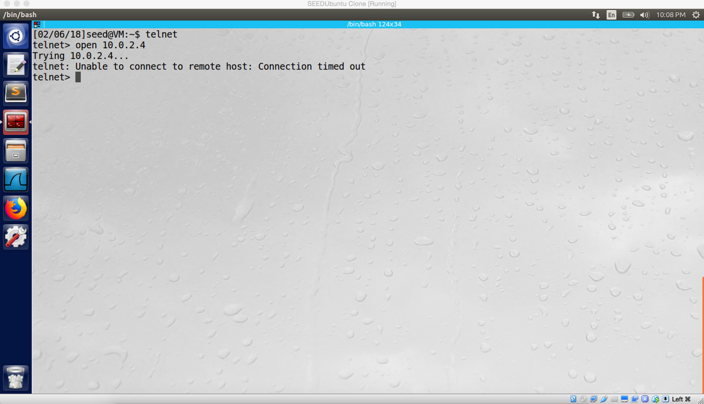

screenshot.4 The rule is added successfully, VM B cannot telnet to VM A

1. Prevent A from visiting https://www.syracuse.edu

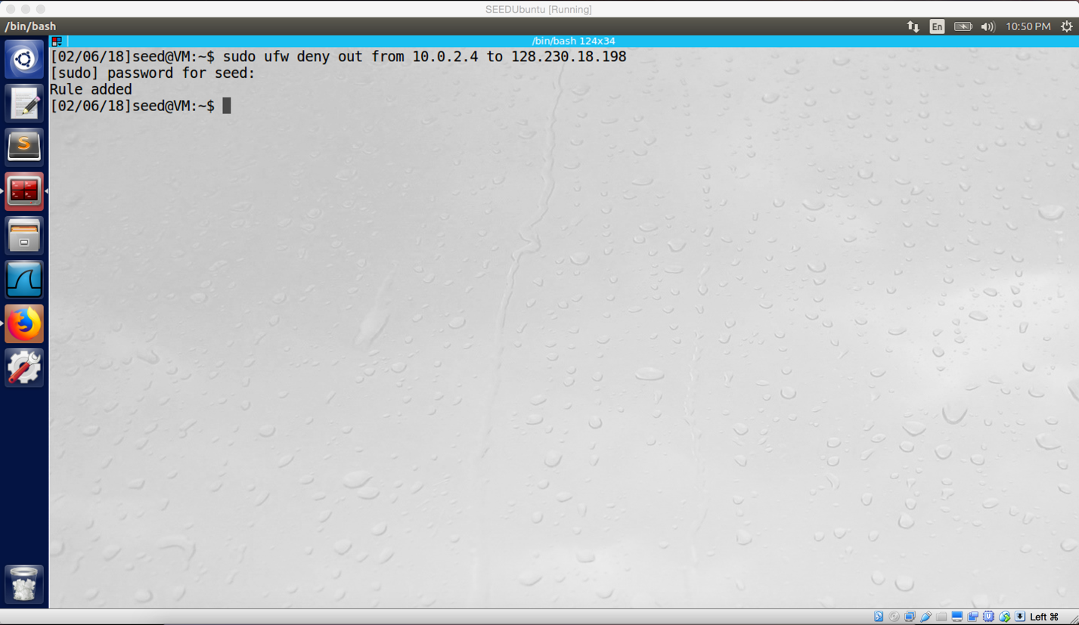

screenshot.5 On VM A. Add rule to block www.syracuse.edu

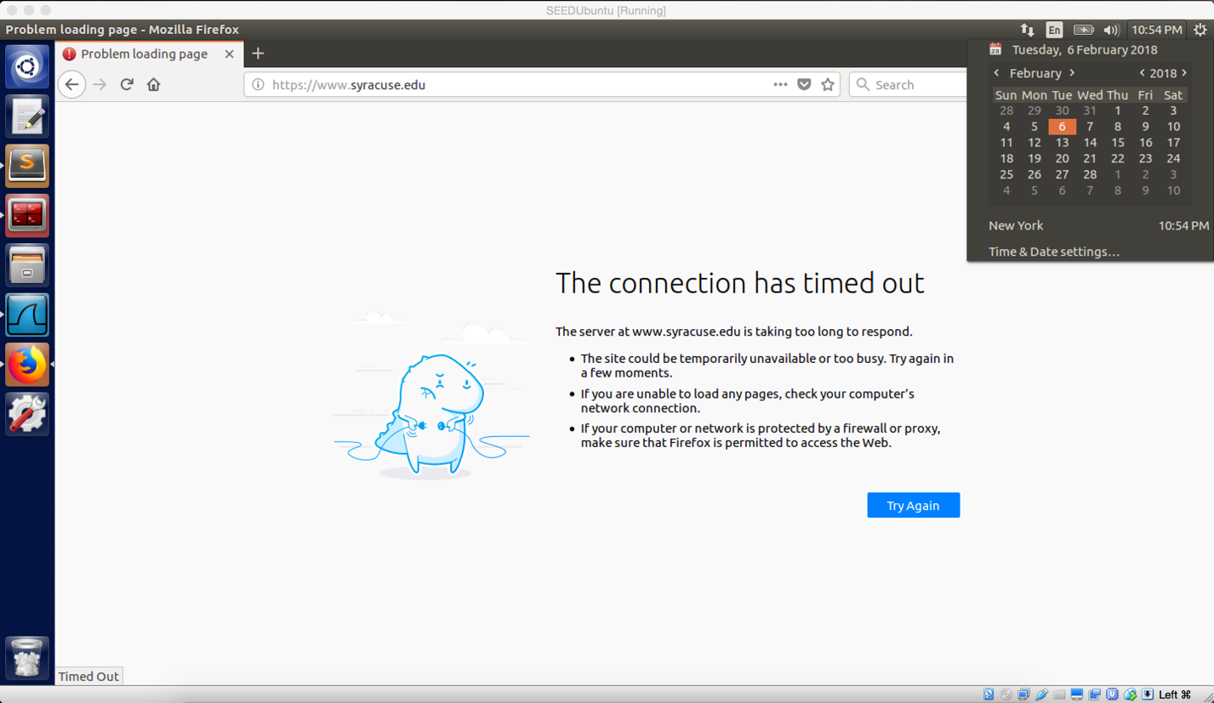

screenshot.6 Successfully blocked this website.

**Observation:**

For this task, I use ufw to add three rules on the firewall of VM A. The first rule is to prevent VM A doing telnet to VM B (as screenshot 1 and 2 show). The second rule is to prevent VM B doing telnet to VM A (as screenshot 3 and 4 show). And the last rule is to prevent VM A to visit www.syracuse.edu (as screenshot 5 and 6 show).

**Explanation**:

Firewall is a part of computer system, and it has two main functions. The first one is egress. Egress, when the firewall is used to prevent internal user to reach outside. In step 1 and step 3, I did egress. In step 1, I add rule of “sudo ufw deny out from 10.0.2.4 to 10.0.2.5 port 23”, it means ufw prevent user on 10.0.2.4 (VM A) to visit 10.0.2.5 (VM B) by port 23. Because telnet use port 23 by default, it rejects telnetting from VM A to VM B. In step 3, I add rule of “sudo ufw deny out from 10.0.2.4 to 128.230.18.198”, this means ufw prevent user on 10.0.2.4 (VM A) to visit 128.230.18.198 (IP address of SU main website). Ingress, when the firewall is used to prevent attack or connection from outside. In step 2, I did ingress. In this part, I add rule of “sudo ufw deny in from 10.0.2.5 to 10.0.2.4 port 23”, compare to step 1, I change out to in and swap 10.0.2.4 with 10.0.2.5. This rule will reject any telnetting from VM B with port 23.

**Task2**

In this task, I created a module which contains 5 rules. First, prevent VM A do telnet VM B. Second, prevent VM B to telnet VM A. Third, prevent VM A to visit SU main website (www.syracuse.edu). Forth, dropping any ICMP packet from VM B. Last, prevent VM A to visit CUNY main website (www2.cuny.edu).

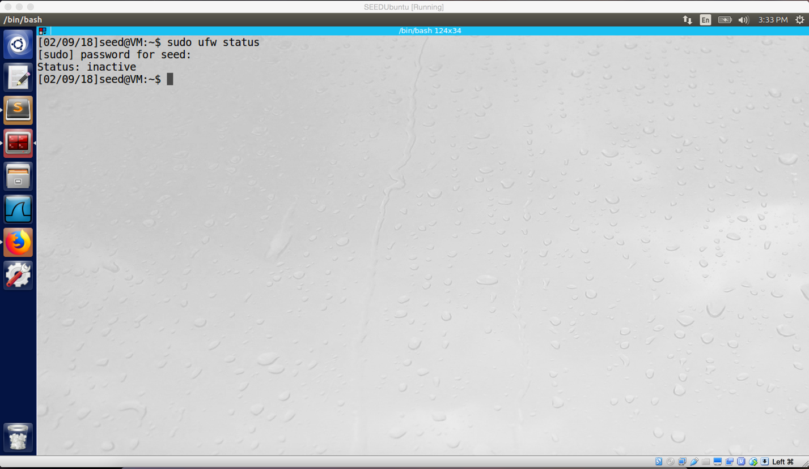

For this task, I disable the ufw firewall firstly

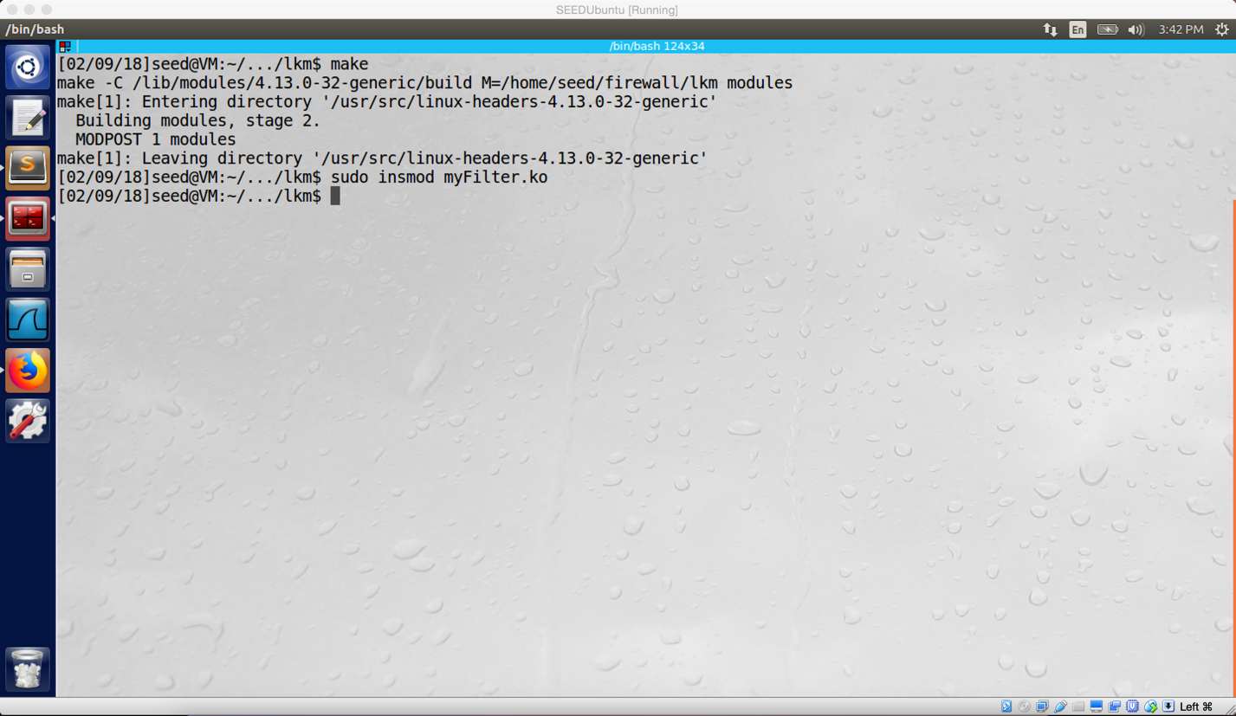

Insert my module to kernel

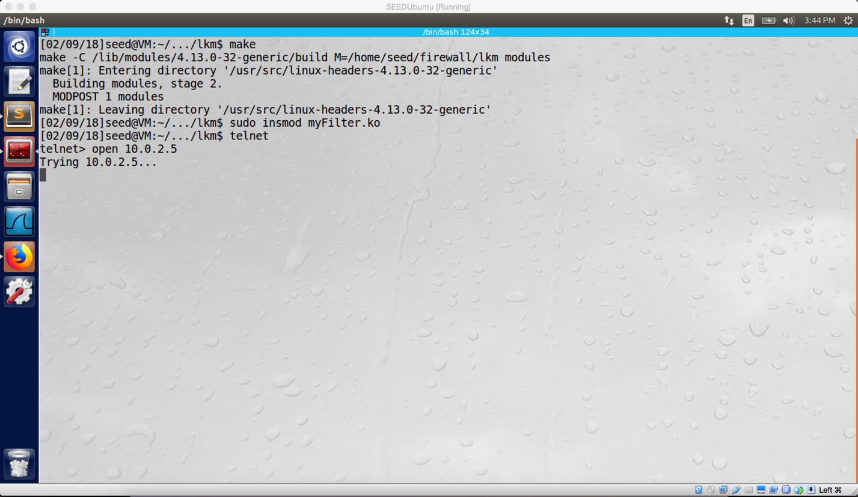

For rule 1, the host machine VM A cannot telnet VM B

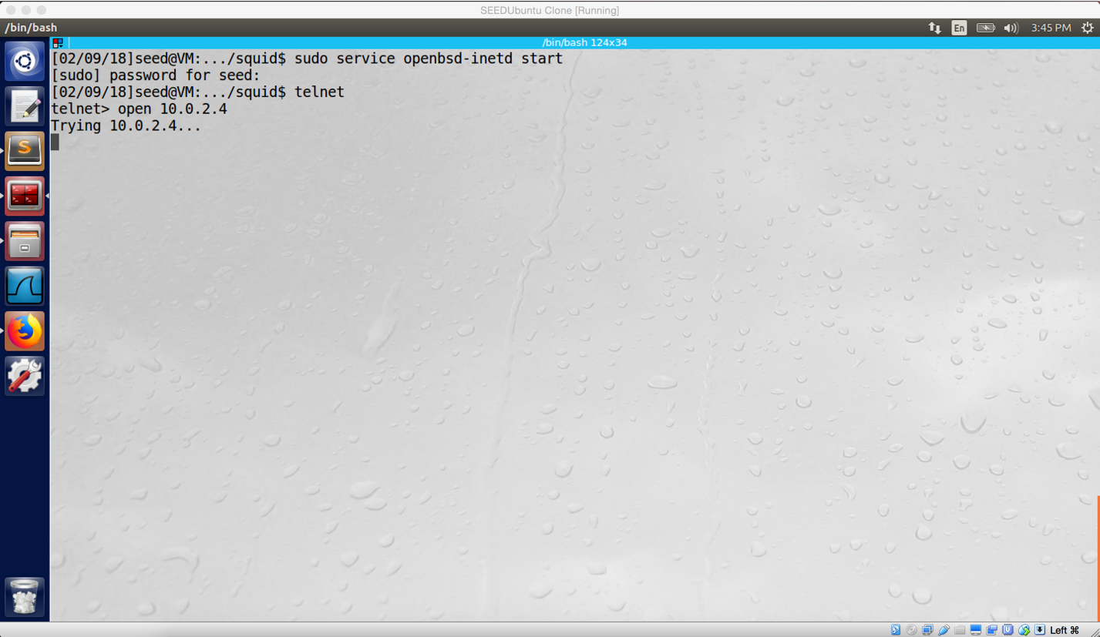

For rule 2, the VM B cannot telnet VM A

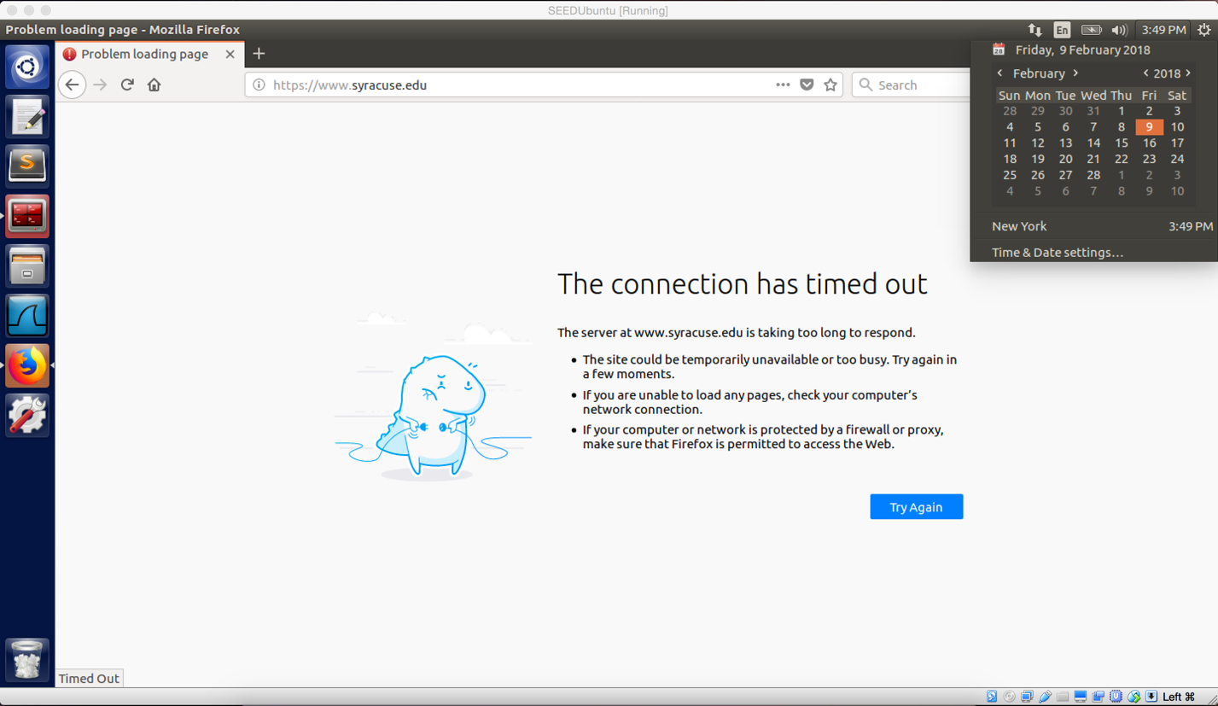

For rule 3, successfully prevent VM A to visit SU main website

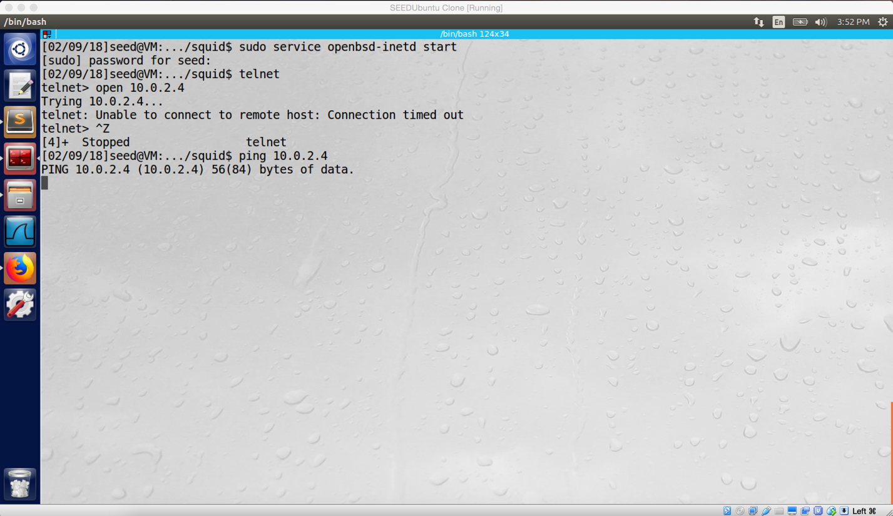

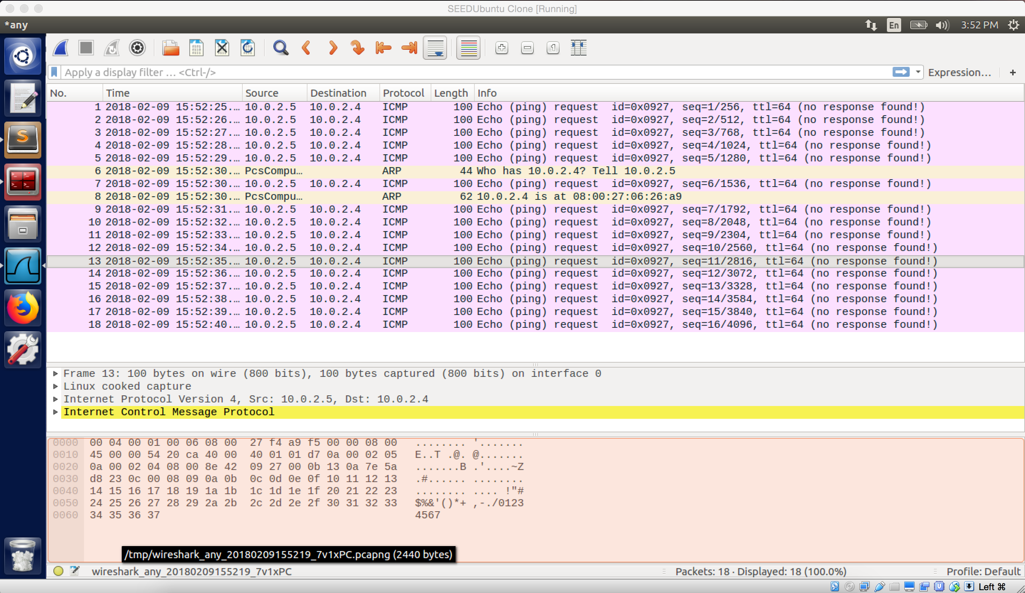

For rule 4, ICMP request from VM B to VM A does not success, there is no reply send back from VM A.

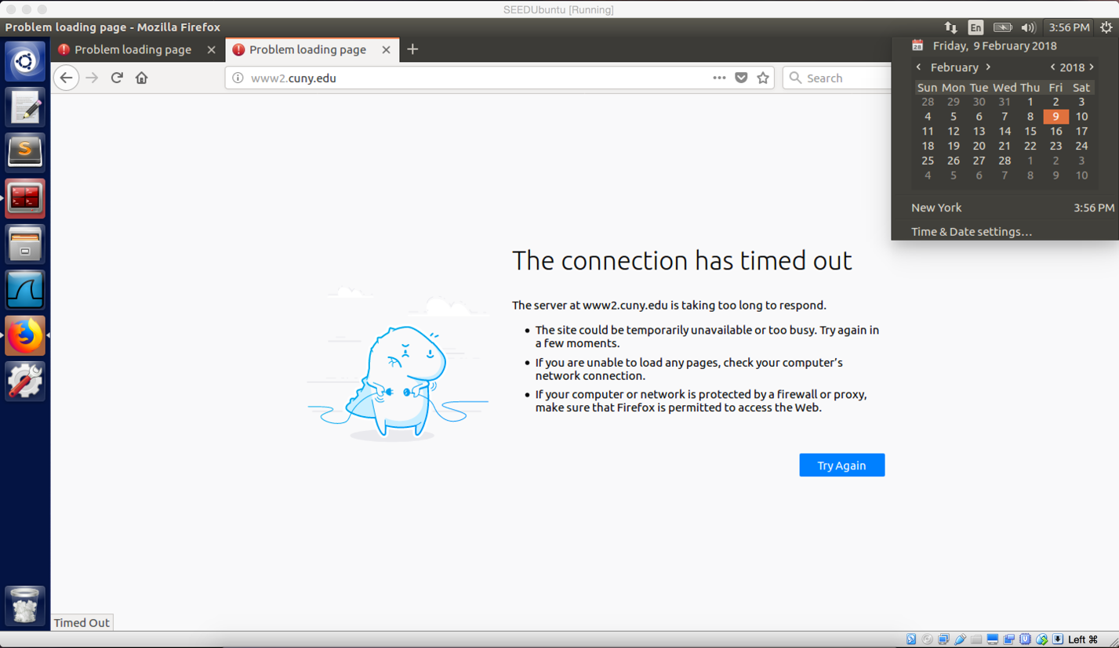

For rule 5, VM A cannot visit www2.cuny.edu

**Observation:**

Firstly, I disable the ufw firewall, and then I insert my module into kernel by LKM. As the screenshots showed above. The rule 1, rule 2 and rule 3 have the same effect as the ufw firewall rules which we did in task 1. Rule 4 is a new rule; this rule will prevent ICMP packet from VM B. The last rule is similar to rule 3, it blocks www2.cuny.edu, so the user on the host machine cannot visit this website.

**Explanation:**

This task is done by two main mechanisms, LKM (loadable kernel module) and Netfilter. The LKM allows us to add new module into kernel. Netfilter provides several hooks in incoming and outgoing paths, so we can insert our module (by LKM) into these hooks, and then we can manipulate packets when they pass these hooks. For rule 1, I block any TCP packet with port 23 and destination IP address 10.0.2.5, so VM A is not able to telnet VM B; moreover, we should set hooknum to NF_INET_POST_ROUTING. For rule 2, I block any TCP packet with port 23, and source IP address 10.0.2.5, so VM B cannot telnet the VM A; moreover, we should set hooknum to NF_INET_PRE_ROUTING. For rule 3, I block packets with destination IP address of 128.230.18.198 (SU website address), so the host machine cannot visit SU website; moreover, we should set hooknum to NF_INET_POST_ROUTING. For rule 4, I block any ICMP packet with source IP address of 10.0.2.5, so any ICMP packet from VM B will be discarded; moreover, we should set hooknum to NF_INET_PRE_ROUTING. For rule 5, I block packets with destination IP address of 128.228.0.52, so any packet go to such IP address will be blocked; moreover, we should set hooknum to NF_INET_POST_ROUTING.

setUpFilter, and removeFilter are same as professor’s code. However, we may change hooknum when we want to apply filter. Because we should insert modules into different hook by doing different filtering (ingress, egress).

//get source IP address in char array

sprintf(ip_dst, "%d.%d.%d.%d", ((unsigned char *)&iph->daddr)[0], ((unsigned char *)&iph->daddr)[1],

((unsigned char *)&iph->daddr)[2], ((unsigned char *)&iph->daddr)[3]);

//get destination IP address in char array

sprintf(ip_src, "%d.%d.%d.%d", ((unsigned char *)&iph->saddr)[0], ((unsigned char *)&iph->saddr)[1],

((unsigned char *)&iph->saddr)[2], ((unsigned char *)&iph->saddr)[3]);

//prevent VM A telnet VM B

if (iph->protocol == IPPROTO_TCP && (tcph->dest == htons(23) || tcph->source == htons(23))&& strcmp(ip_dst, "10.0.2.5") == 0) {

printk(KERN_INFO "Dropping telnet packet to %s\n", ip_dst);

return NF_DROP;

}

//prevent VM B telnet VM A

if (iph->protocol == IPPROTO_TCP && (tcph->dest == htons(23) || tcph->source == htons(23))&& strcmp(ip_src, "10.0.2.5") == 0) {

printk(KERN_INFO "Dropping telnet packet from %s\n",ip_src);

return NF_DROP;

}

//prevent host machine to visit www.syracuse.edu

if (strcmp(ip_dst, "128.230.18.198") == 0){

printk(KERN_INFO "Dropping packet to %s\n", ip_dst);

return NF_DROP;

}

//prevent ICMP request/reply from VM B (10.0.2.5)

if (iph->protocol == IPPROTO_ICMP && strcmp(ip_src, "10.0.2.5") == 0){

printk(KERN_INFO "Dropping ICMP packet from VM B %s", ip_src);

return NF_DROP;

}

//prevent host machine to visit www2.cuny.edu

if(strcmp(ip_dst, "128.228.0.52") == 0){

printk(KERN_INFO "Dropping packet to %s\n", ip_dst);

return NF_DROP;

}

**Question 1:**

Netfilter defines five hooks for IPv4, they are

NF_IP_PRE_ROUTING: All incoming packets will pass this hook before any routing decision is made.

NF_IP_LOCAK_IN: When the routing decides that the following packet is for the host machine, and then the packet will pass this hook.

NF_IP_FORWARD: If the following packet is not for the host, and then the packet will forward to other hosts and reach this hook.

NF_IP_LOCAL_OUT: Packets generated by the local host will sent to this hook first.

NF_IP_POST_ROUTING: When a packet is going out of the host, it will pass this hook.

We can insert our module program into these hooks. When packets arrive in these hooks, our module program will get involve. As a result, we can modify or filter these packets.

Routing

NF_IP_POST_ROUTING

NF_IP_ FORWARD

NF_IP_PRE_ROUTING

Network Stack

Routing

NF_IP_LOCAL_IN

NF_IP_LOCAL_OUT

**Question 2:**

For ingress, we want to inspect incoming packet, so we should place a hook before the packet is being routed or processed, such as NF_IP_PRE_ROUTING.

For egress, we we want to inspect outgoing packet, se we should place a hook after a packet is being routed or processed, such as NF_IP_PRE_ROUTING.

**Question 3:**

Yes, by placing our filter program on hooks, we can block/filtering packets, and we also can modify packets.

**Task3**

For this task, I choose to use a website with static IP address which is www.syracuse.com

**Task 3.a**

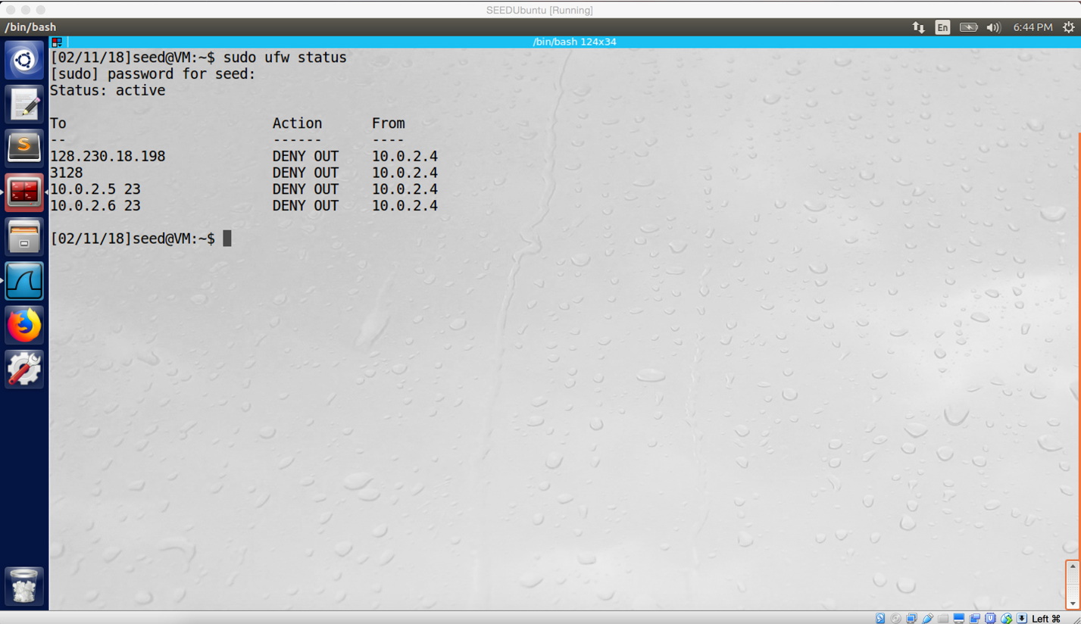

Screenshot 1 on VM A. Adding ufw rule to block VM A telnet VM C successfully

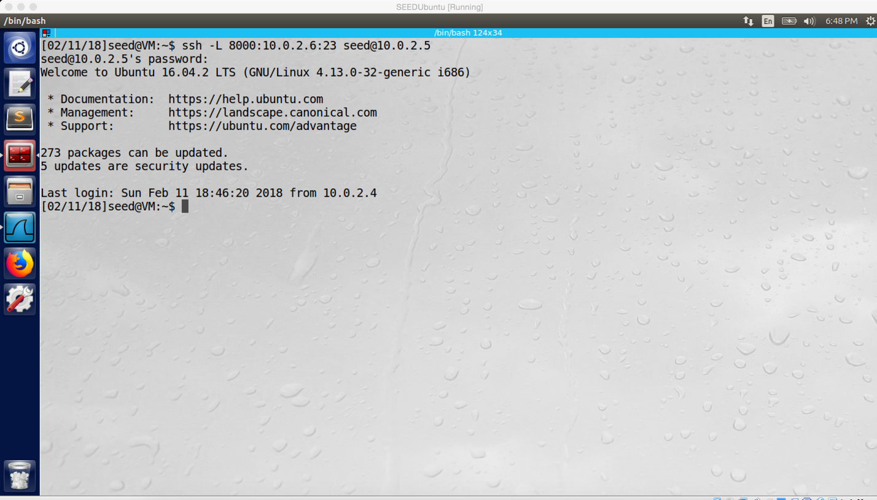

Screenshot 2 on VM A. Successfully build SSH tunnel from VM A to VM B

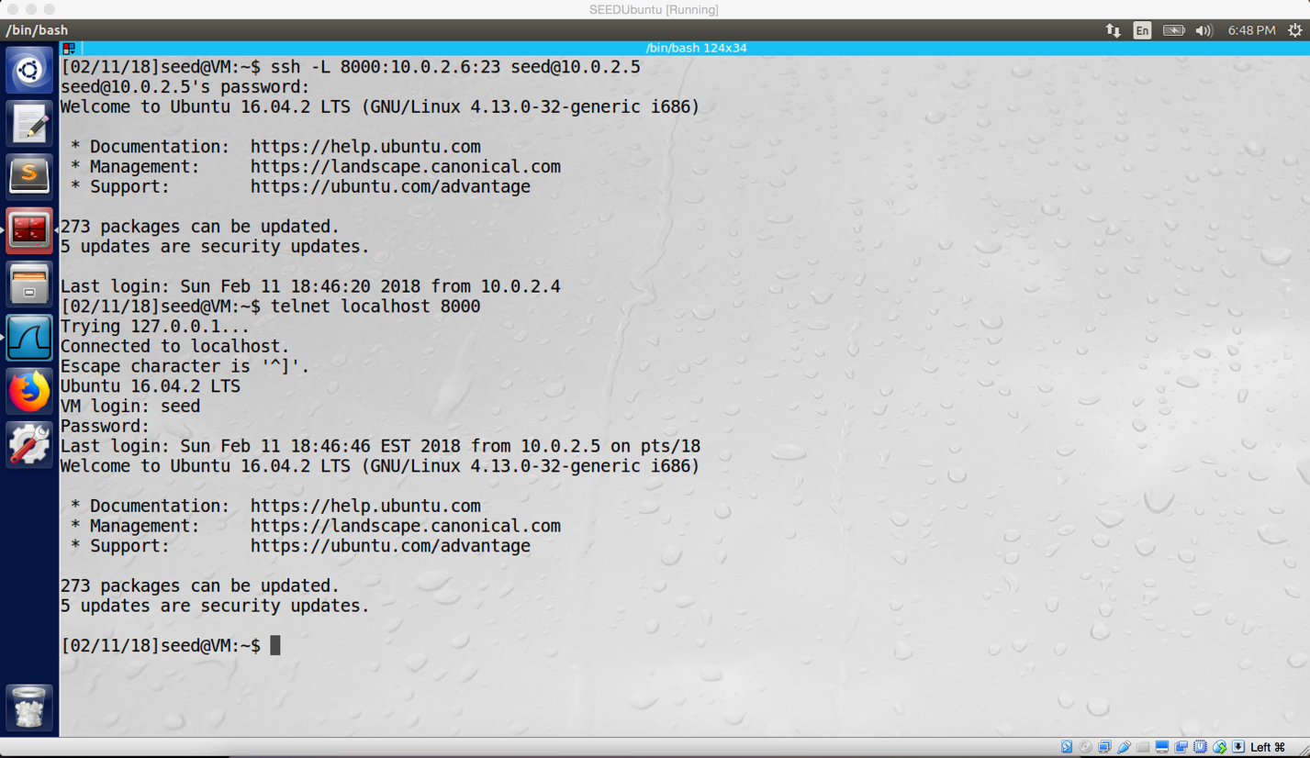

Screenshot 3 on VM A. Successfully telnetting from VM A to VM C by SSH tunnel

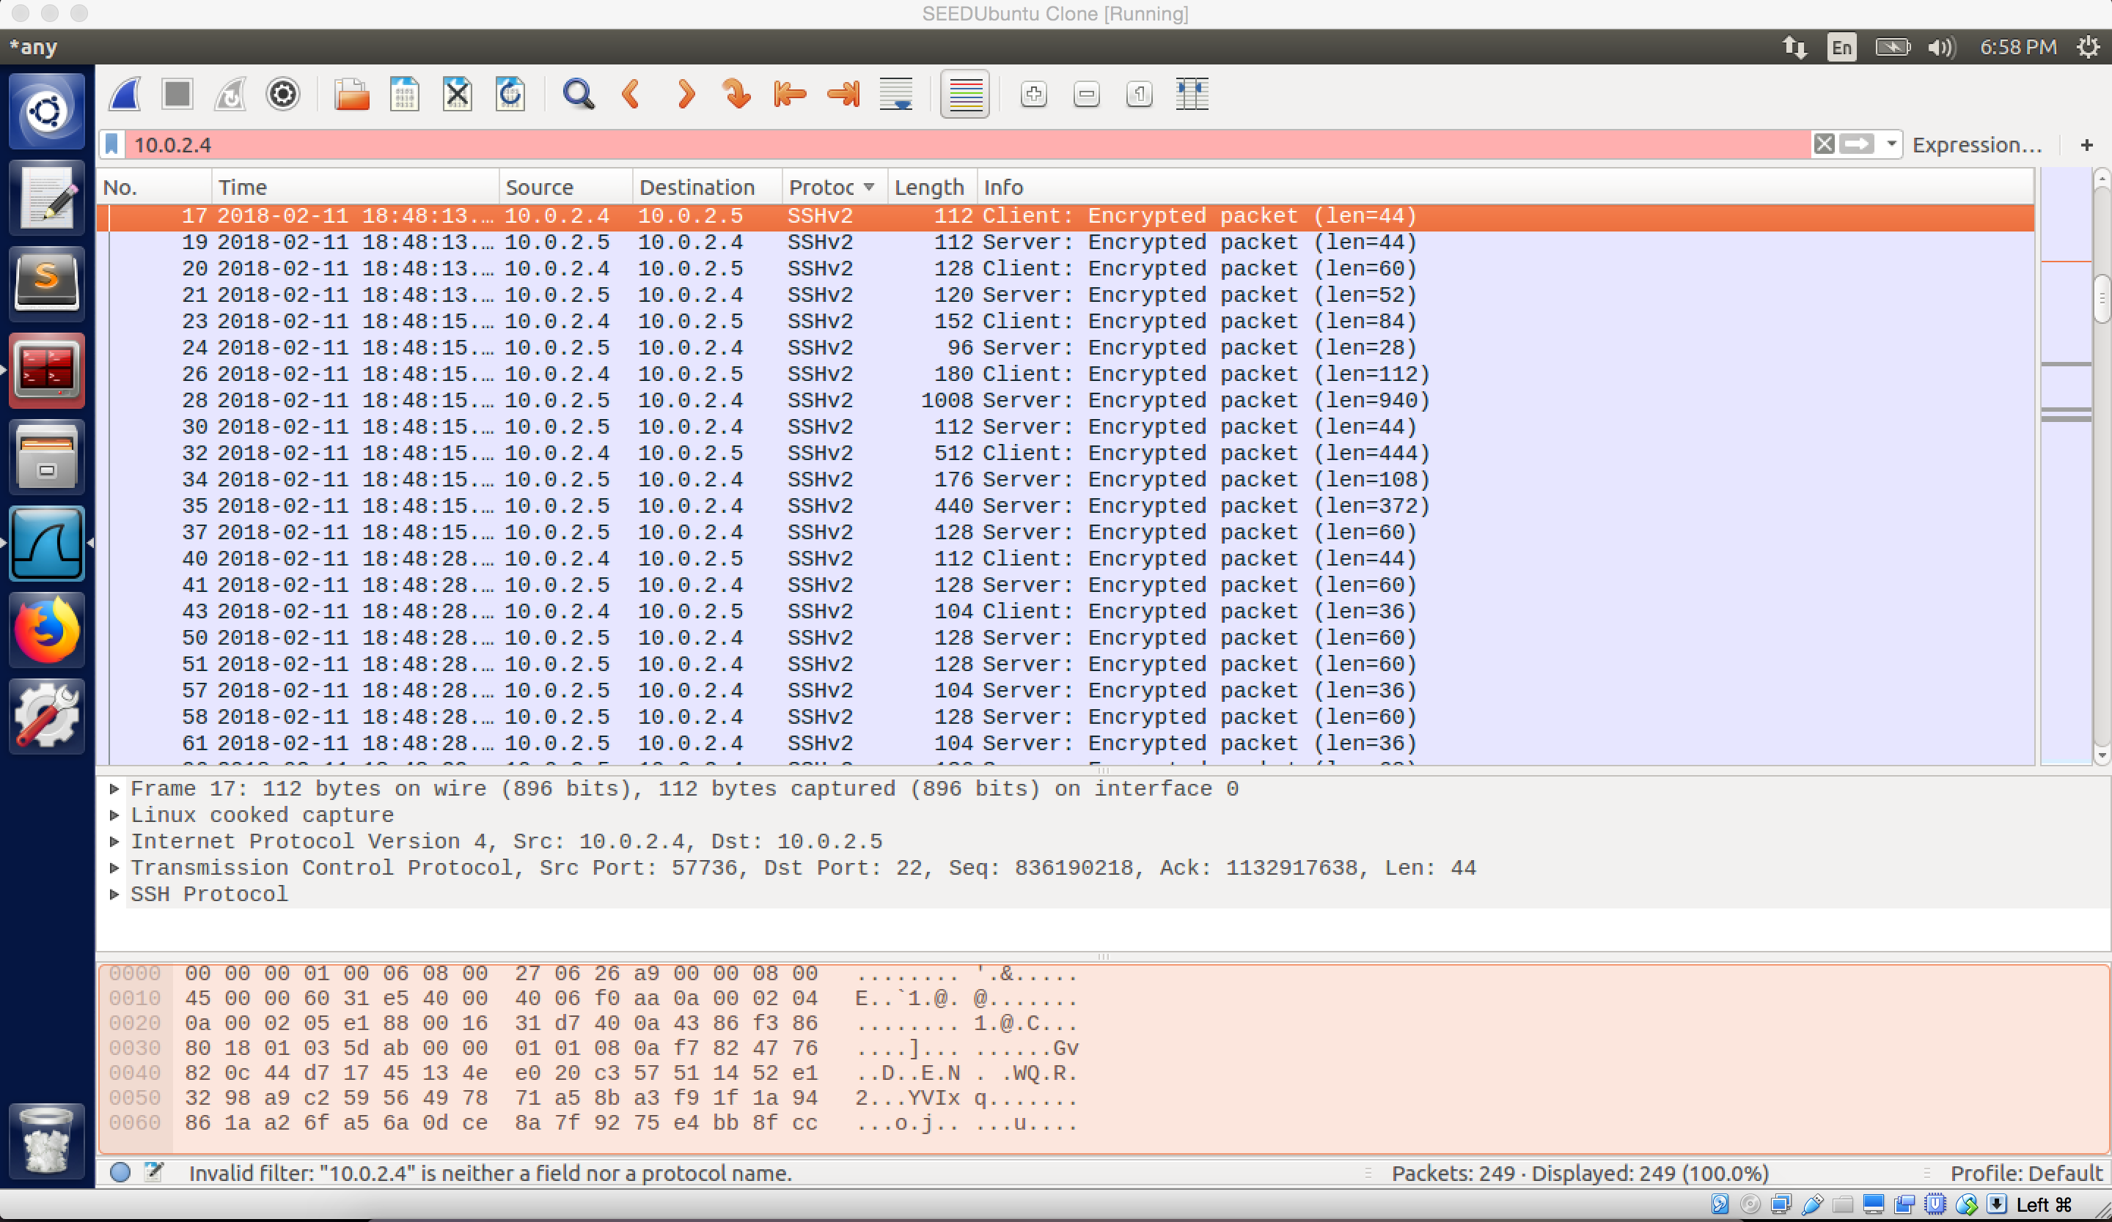

screenshot 4. SSH tunnel is established between VM A and VM B.

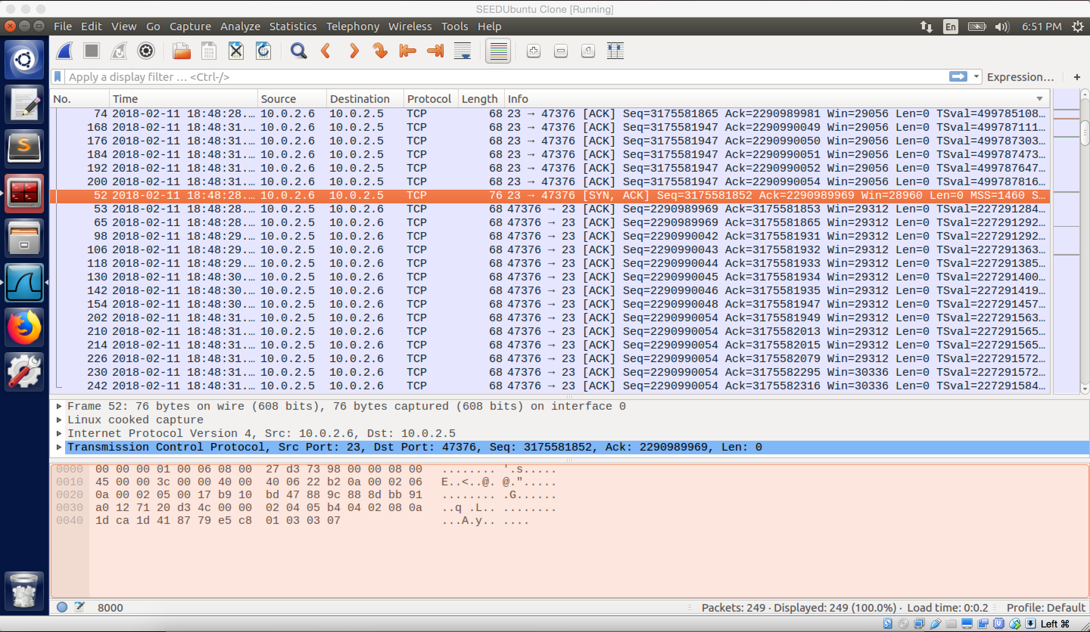

screenshot 5.1. TCP packets transfer between VM B and VM C. VM C received and send out TCP packets by port 23

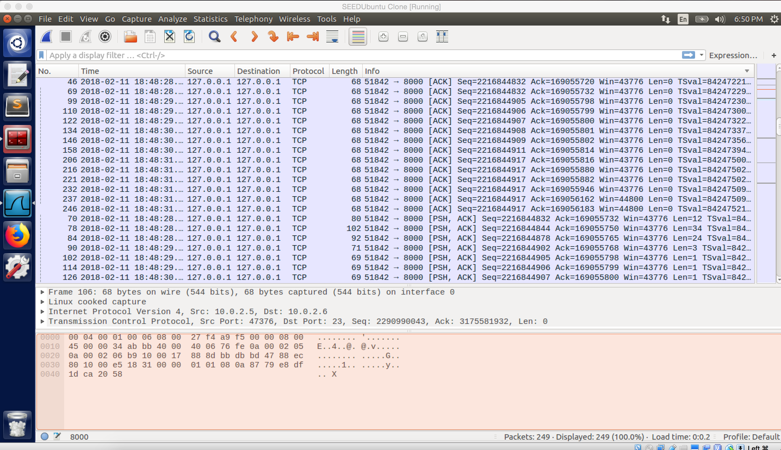

screenshot 5.2. TCP packet go through port 8000

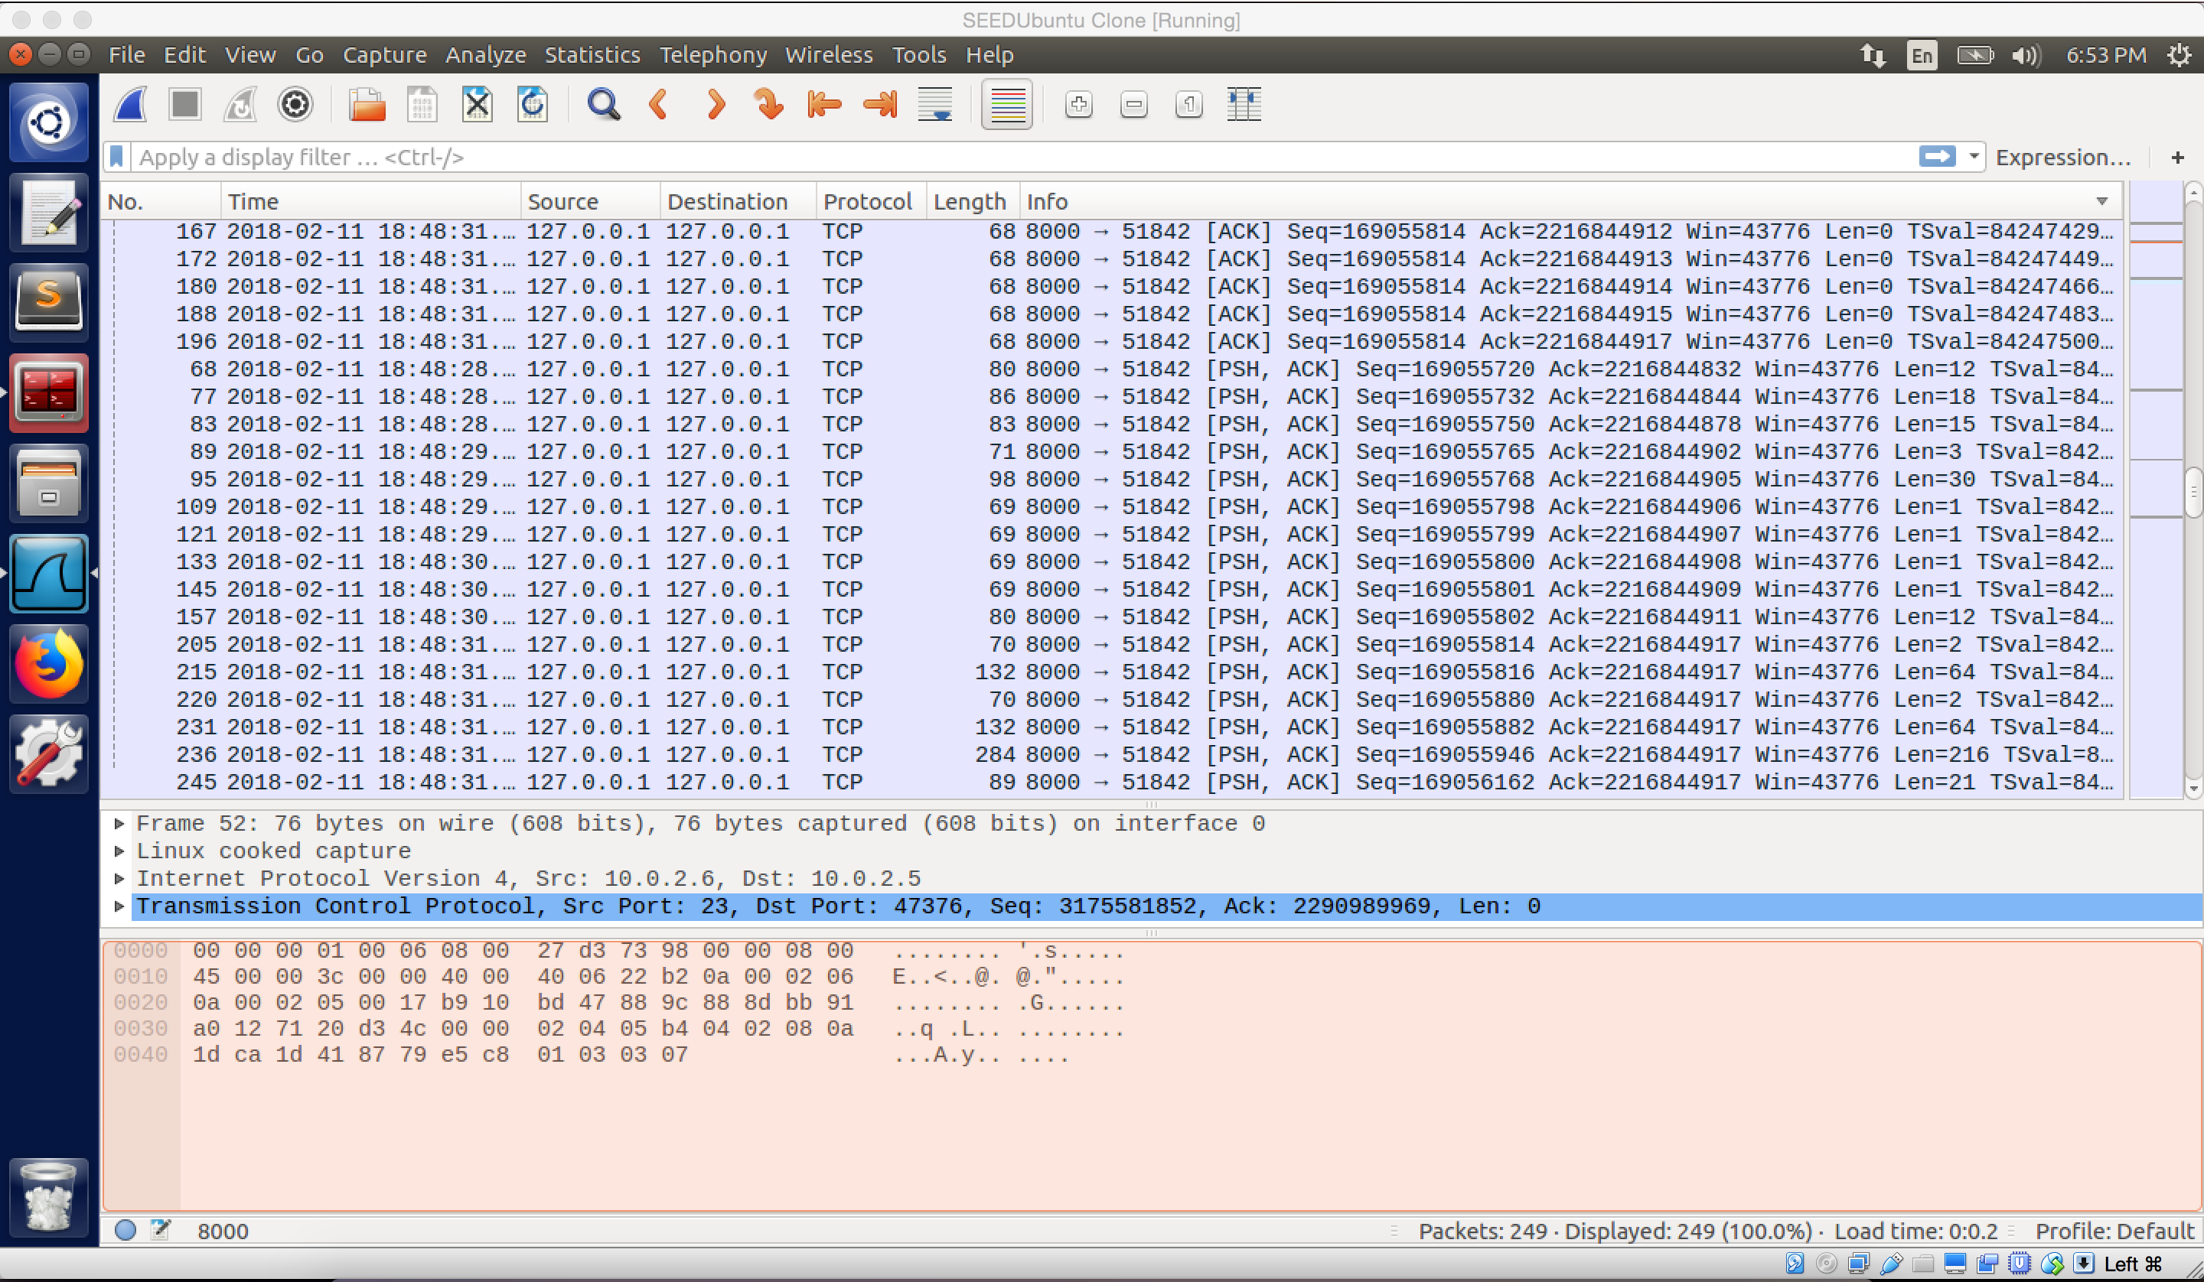

screenshot 5.3, TCP packets are going through port 8000.

**Observation and Explanation:**

I did this task before I finished task 2, so I use ufw to finish this task. First, I start ufw firewall and add rule of “sudo ufw deny out from 10.0.2.4 to 10.0.2.6 port 23”to it, this rule will prevent packet out from VM A to VM C in port 23(screenshot 1). Because telnet uses port 23 by default, telnet is blocked.

And then I typed “ssh –L 8000:10.0.2.6:23 seed@10.0.2.5”, this command established a SSH tunnel between VM A and VM B (screenshot 2). So using this tunnel, VM A will send out packets by port 8000 to VM B; after VM B received these packets, it will forward these packets to port 23 of VM C. After VM C received packets, it can send packets back on the same path with reverse order.

After the SSH tunnel is established, we can do telnet from VM A to VM C by command “telnet localhost 8000”, as screenshot 3 shows we successfully telnet from VM A to VM C. The screenshot 4 and 5 show the whole traffic, we can see the SSH tunnel is established between VM A and VM B (SSH protocol), and they use this tunnel to transfer packets (screenshot 4). Furthermore, we can see TCP packets are go through port 8000 (screenshot 5.2 and 5.3), and finally received by VM C in port 23; on the other hand, VM C also send packet out via port 23 (screenshot 5.1)

**Task 3.b**

Because Facebook is hard to block, I decide to block SU main website (www.syracue.edu) in this task.

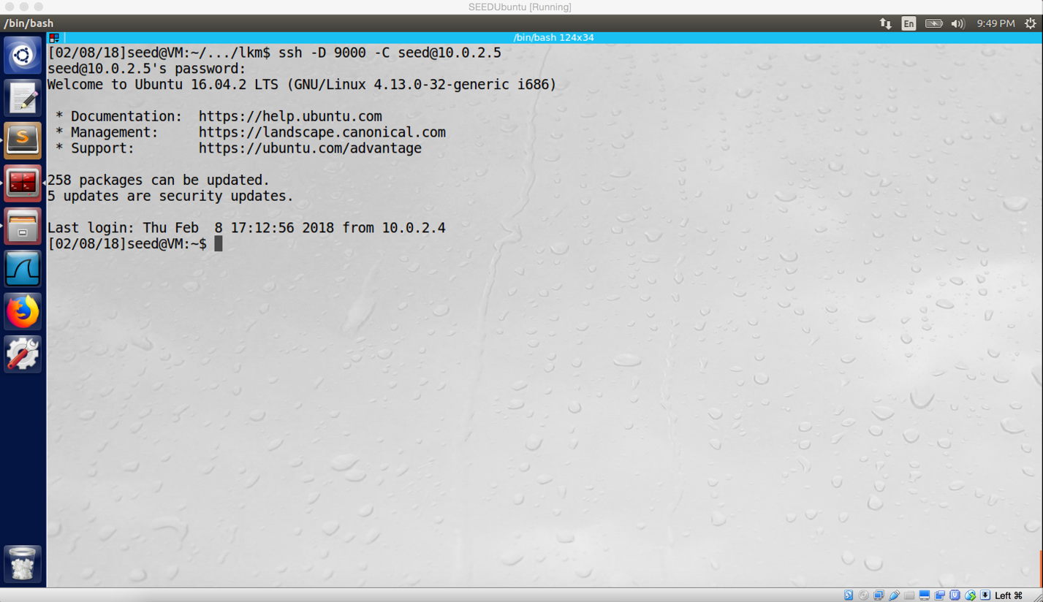

Screenshot 1 on VM A. Successfully establish SSH tunnel between VM A and VM B

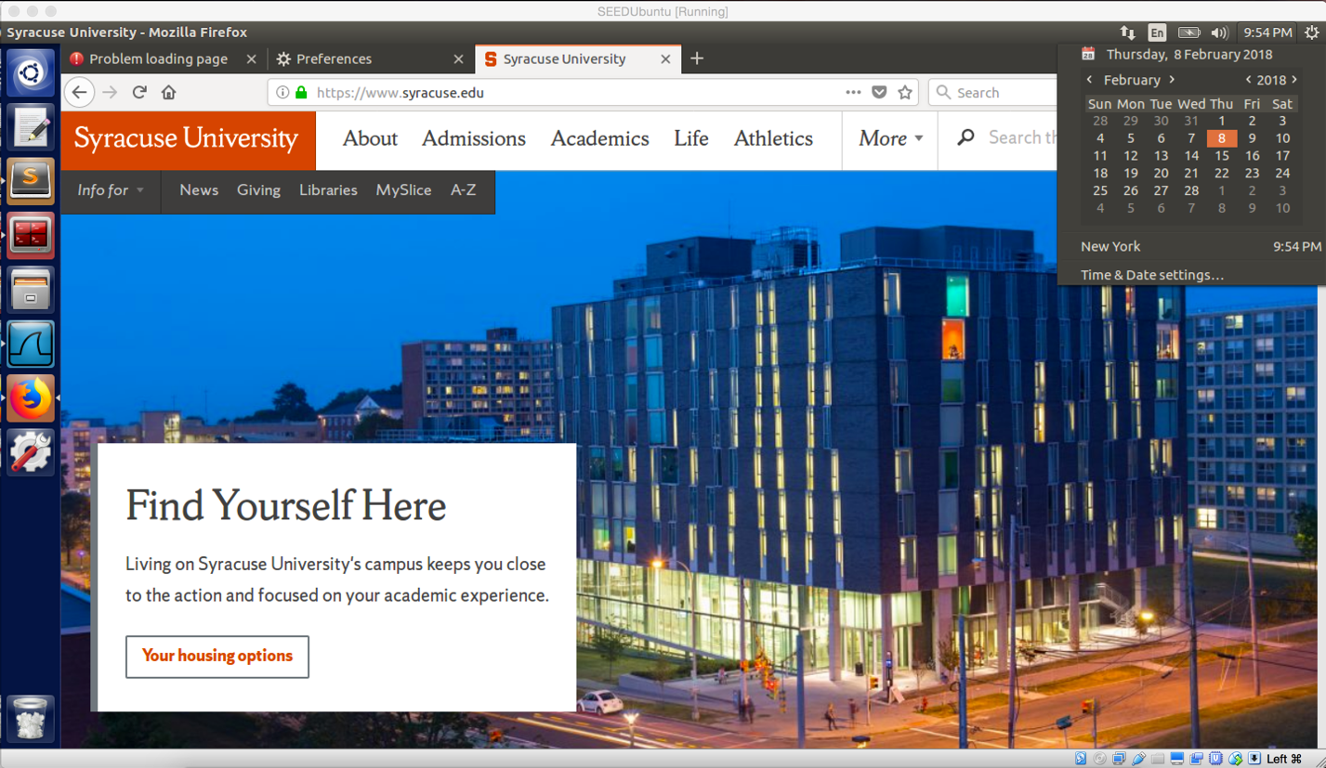

Screenshot 2 on VM A. I can visit SU website

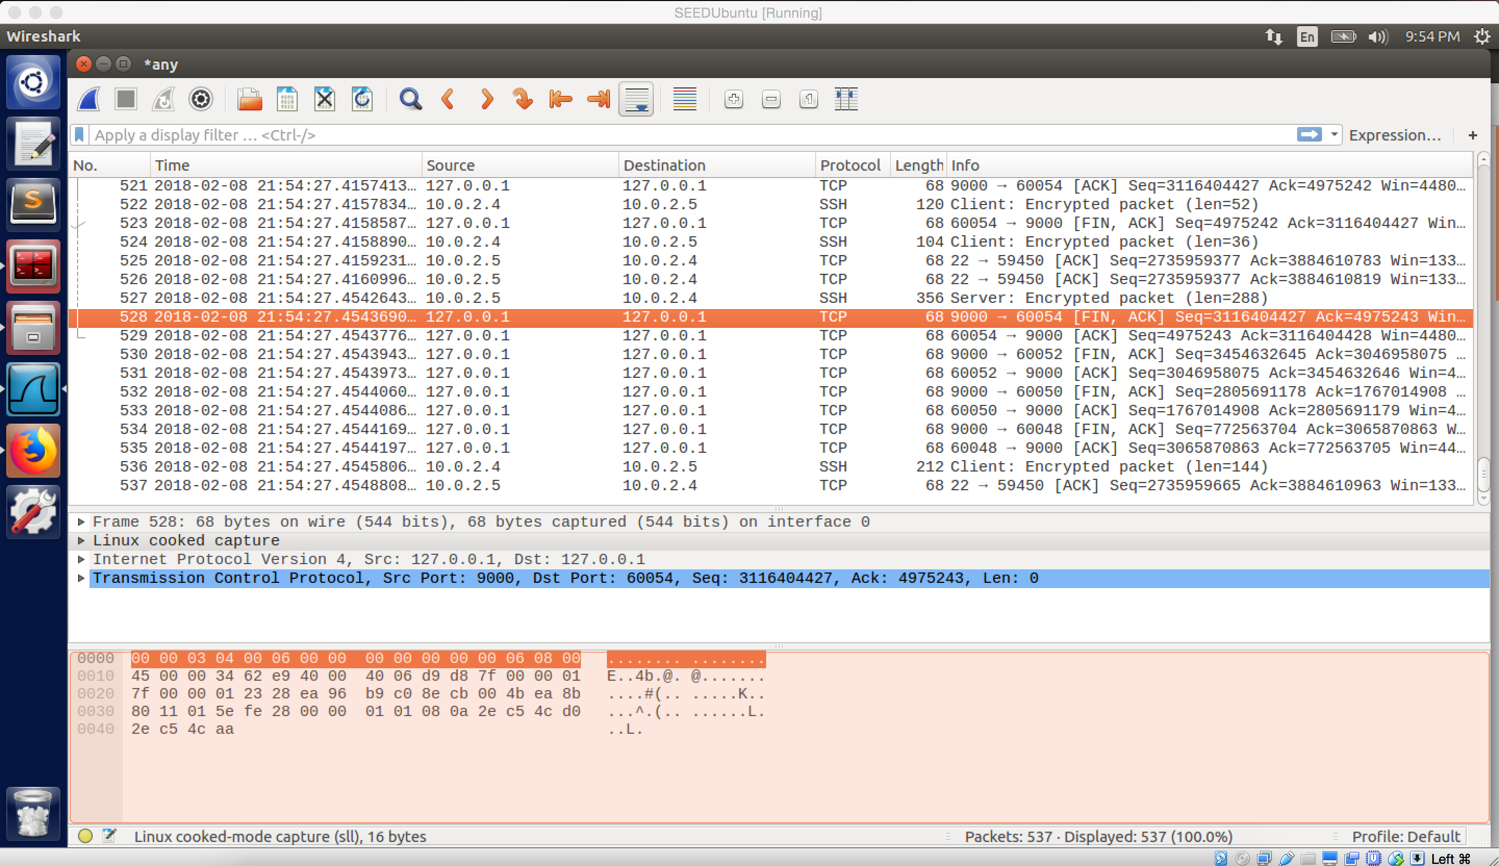

Screenshot 3 on VM A. SSH tunnel is established between VM A and VM B (SSH protocol packet), and Packets go through port 9000. Successfully connect to SU main website, even my netFilter program is still running.

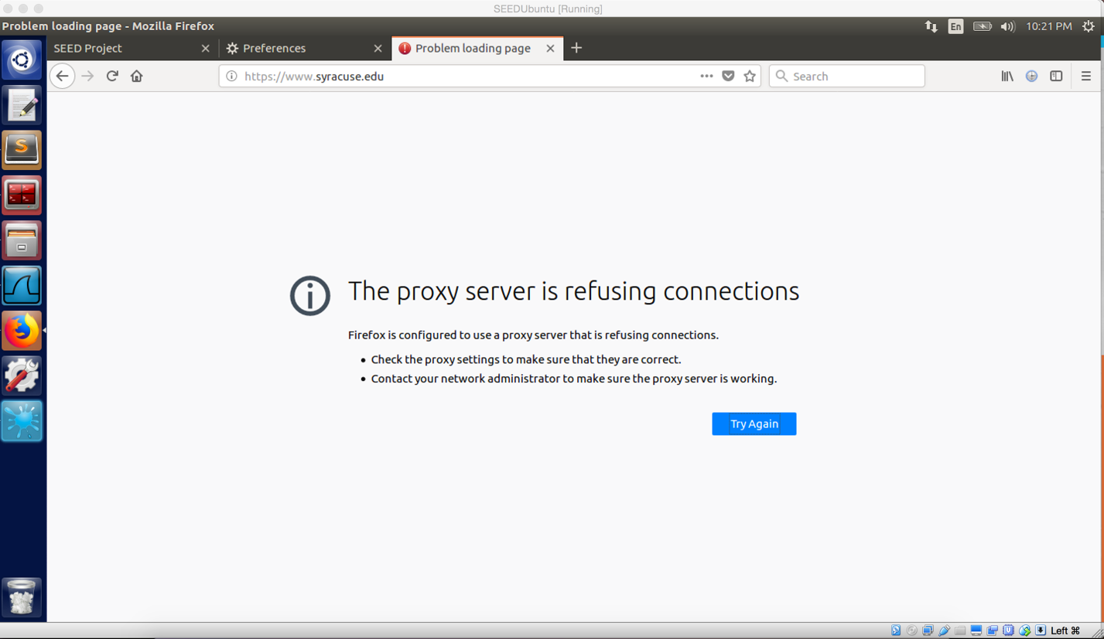

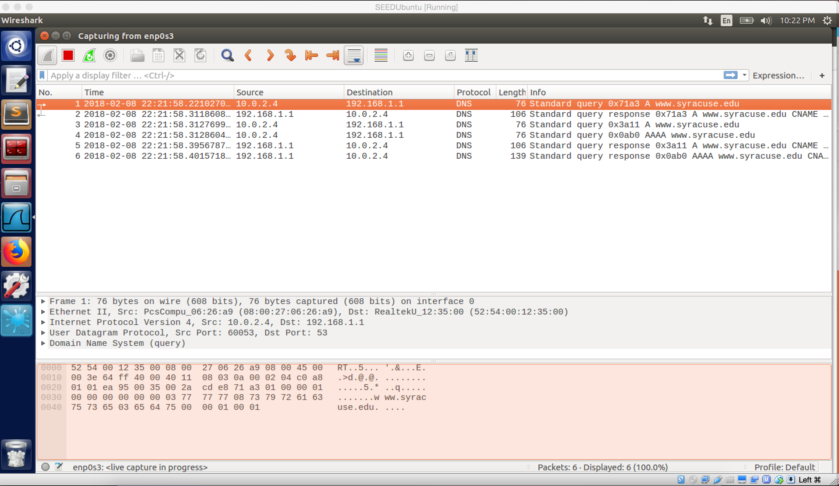

Screenshot 5 on VM A. After I broke the SSH tunnel, I cannot access to SU main website, and the Firefox shows “The proxy server is refusing connections”

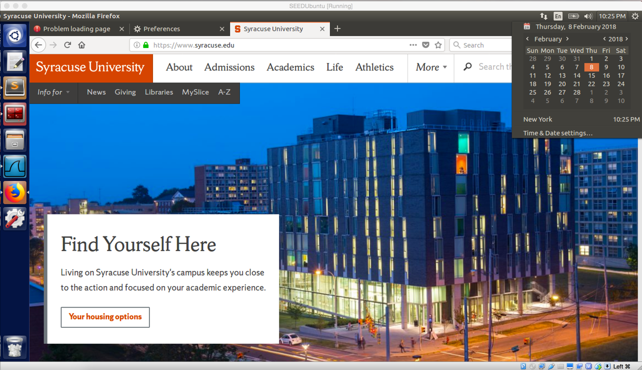

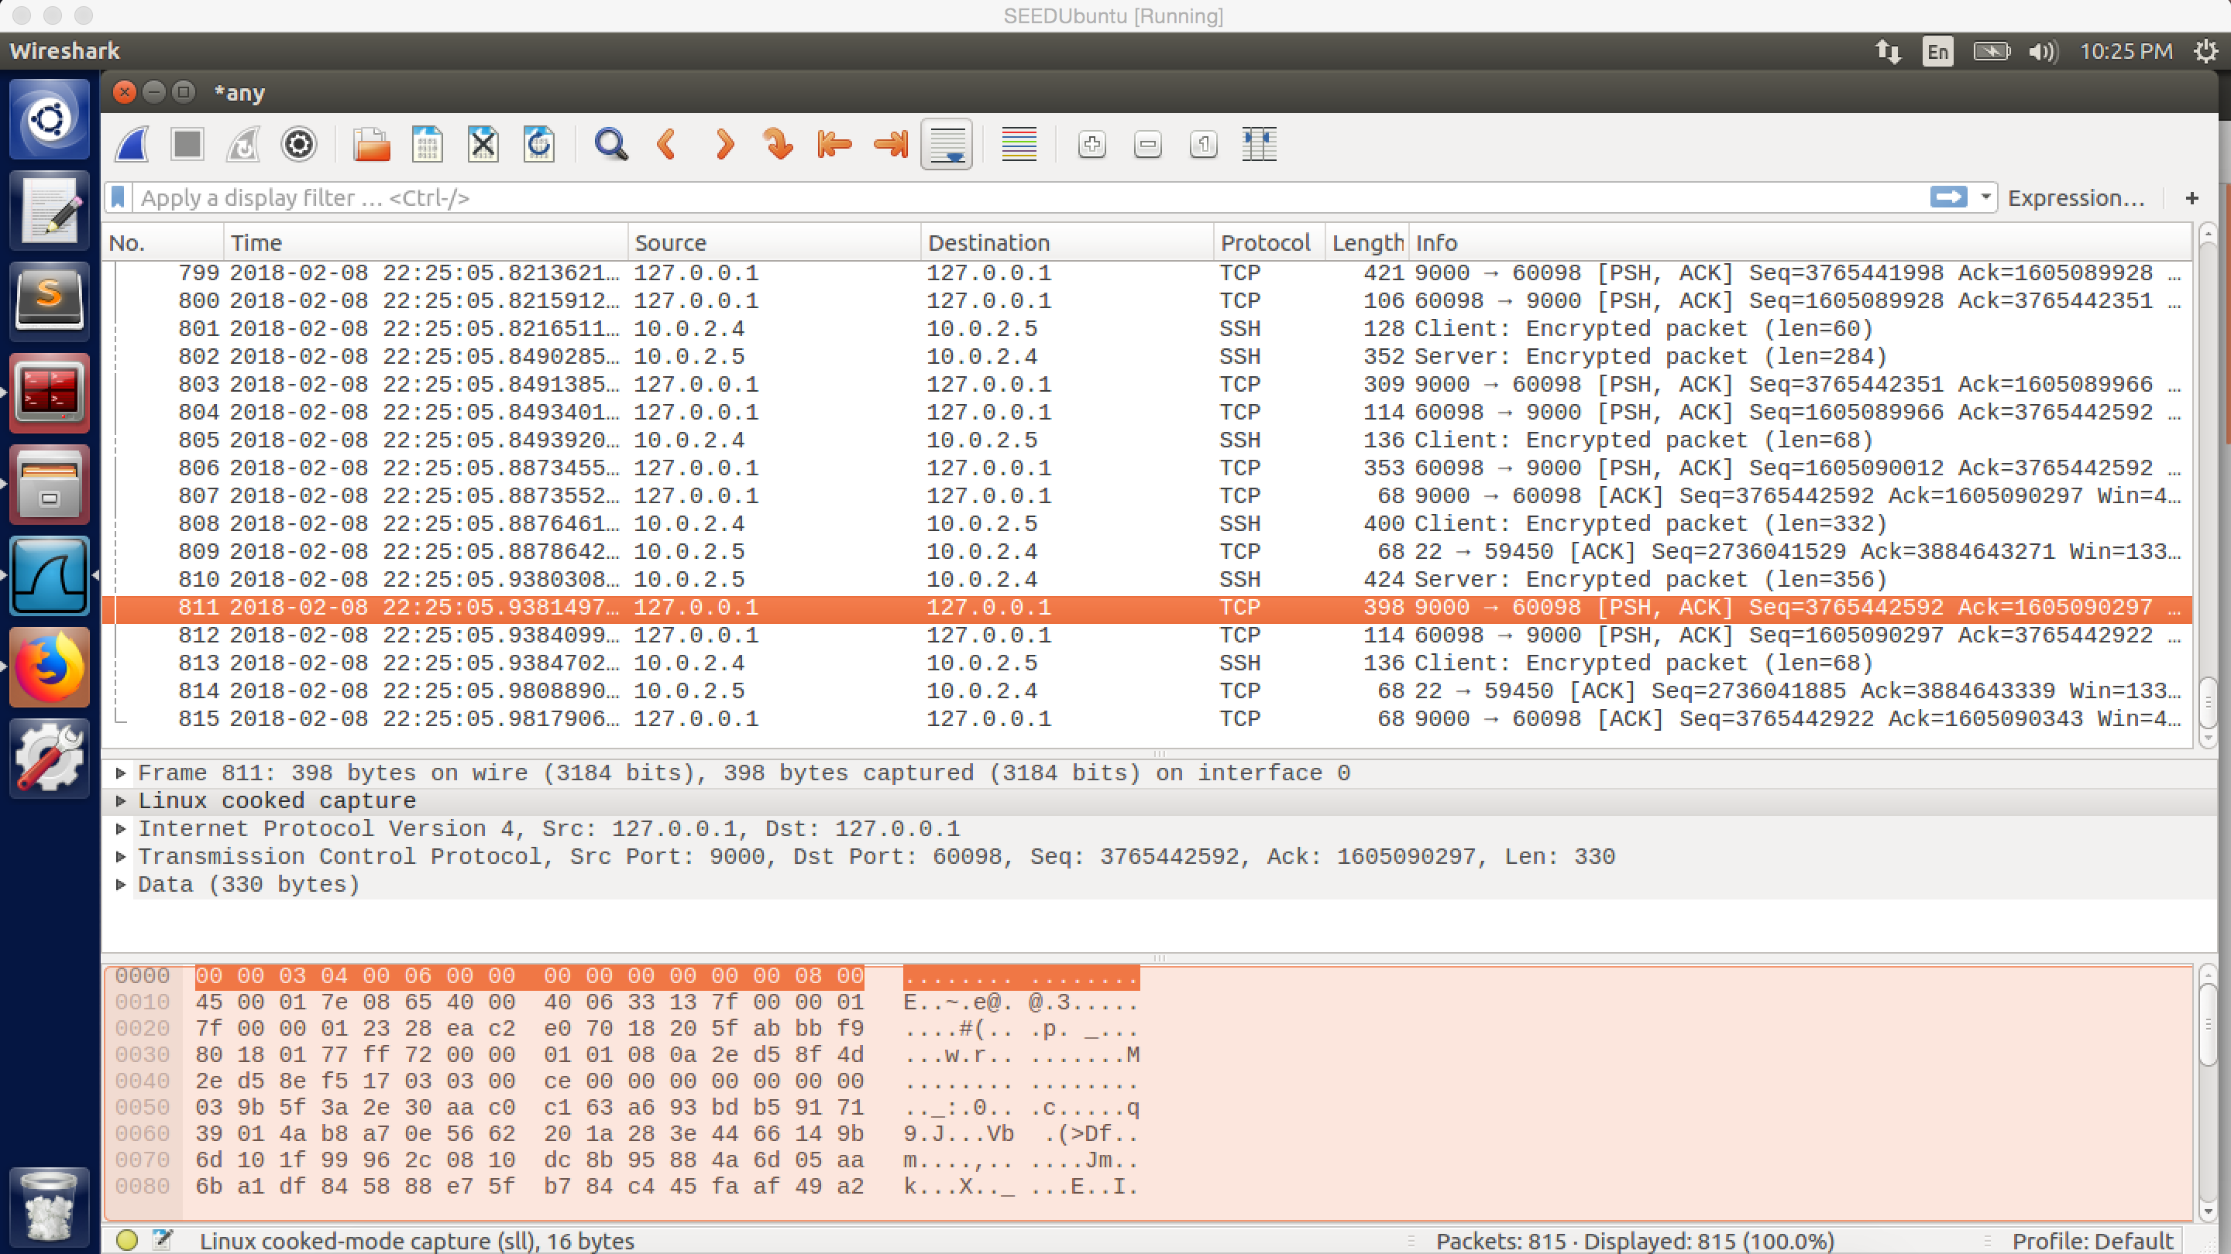

Screenshot 6 on VM A. I can access to SU main website again after I built SSH tunnel from VM A to VM B.

**Observation and Explanation:**

1. Since the SU website is blocked by my module; before I use SOCKS proxy and establish SSH tunnel, the SU main website is blocked, and I cannot visit it on VM A. After I established SSH tunnel between VM A and VM B by command “ssh –D 9000 –C seed@10.0.2.5” (screenshot 1). This command will establish a SSH tunnel between VM A and VM B, and the VM A will use port 9000 to receive and send packet. However, because this time we didn’t specify a destination, we need to set SOCKS proxy to make sure whatever the destination is, it will go through port 9000 (to use the SSH tunnel). After I configured SOCKS proxy on the browser, I can use VM A to connect SU website again (screenshot 2). As the screenshot 3 shows, the SSH tunnel is established between VM A and VM B, they use this tunnel to transport packets (SSH protocol); and the TCP packet is transported via port 9000.
2. After I broke the SSH tunnel, I cannot visit SU website, and the error message shows “The proxy server is refusing connections”. SOCKS is used to forward data to port 9000 and make sure these data can go through the SSH tunnel. However, the tunnel is broken now, so the SOCKS cannot work now. As screenshot 5 shows, there is no SSH tunnel now.
3. After reestablished the SSH tunnel, I can visit the website again. Packets go though the SSH tunnel (packet between 10.0.2.5 and 10.0.2.4 with SSH protocol) and port 9000 as before (screenshot 6).

**Question 4**

The default SSH port is 22, and it is assigned for contacting SSH servers (SSH remote login protocol). Therefore, after I add rule to ufw to block port 22, the SSH tunnel cannot be established anymore (as following screenshots show). However, if we change SSH port from 22 to other number, then we may still establish tunnel to evade egress filtering.

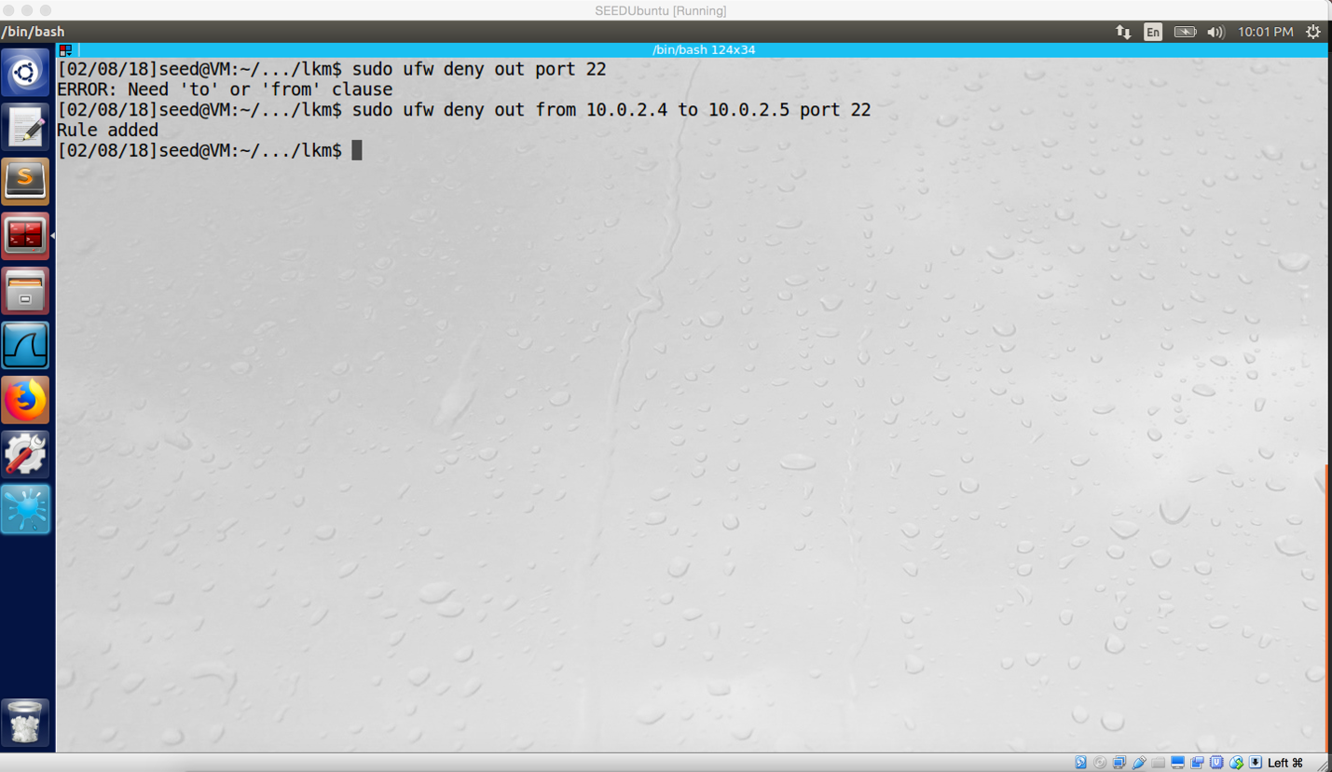

block port 22 from VM A to VM B

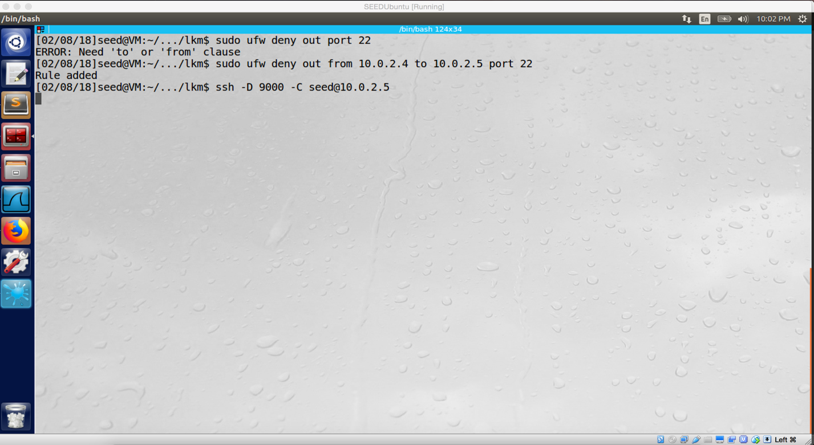

SSH tunnel cannot be established

**Task 4.a**

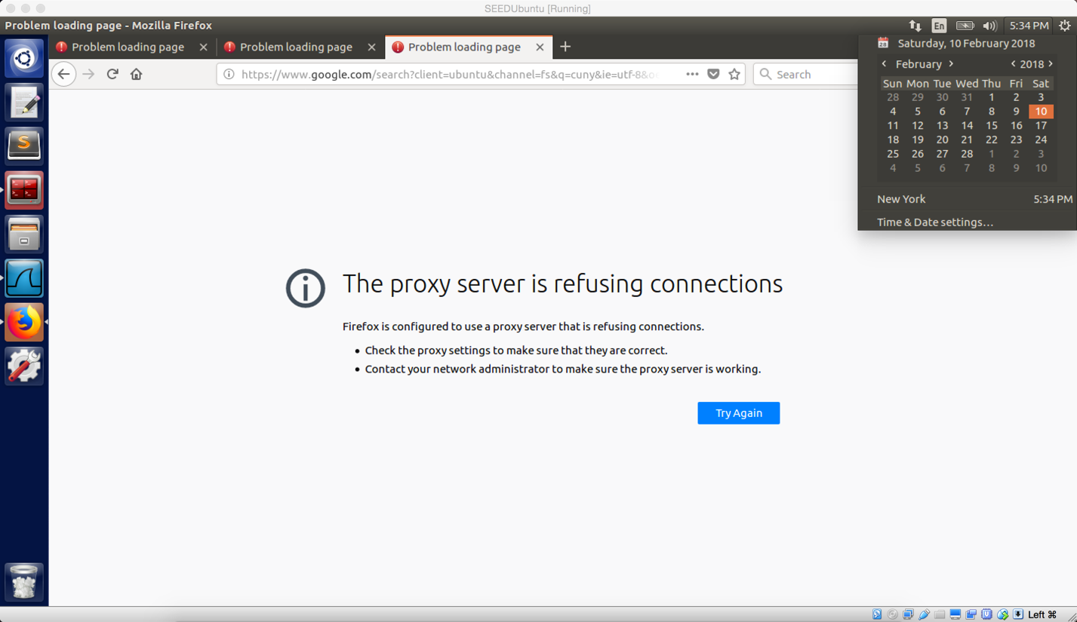

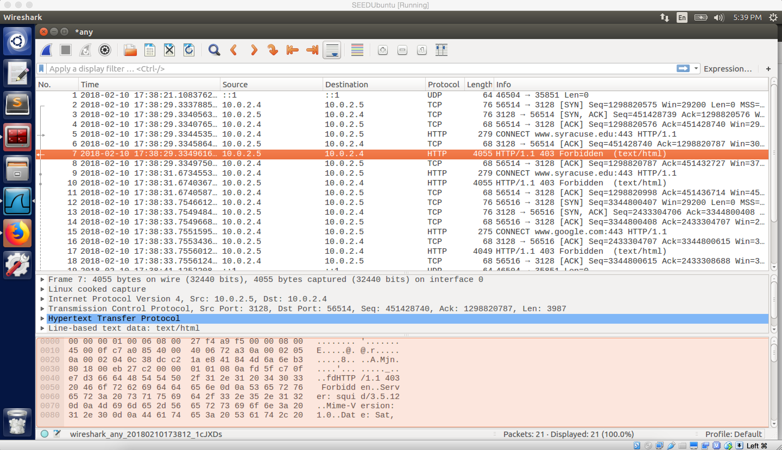

Screenshot 1 on VM A. I try to access SU main website; the browser says “The proxy server is refusing connections”

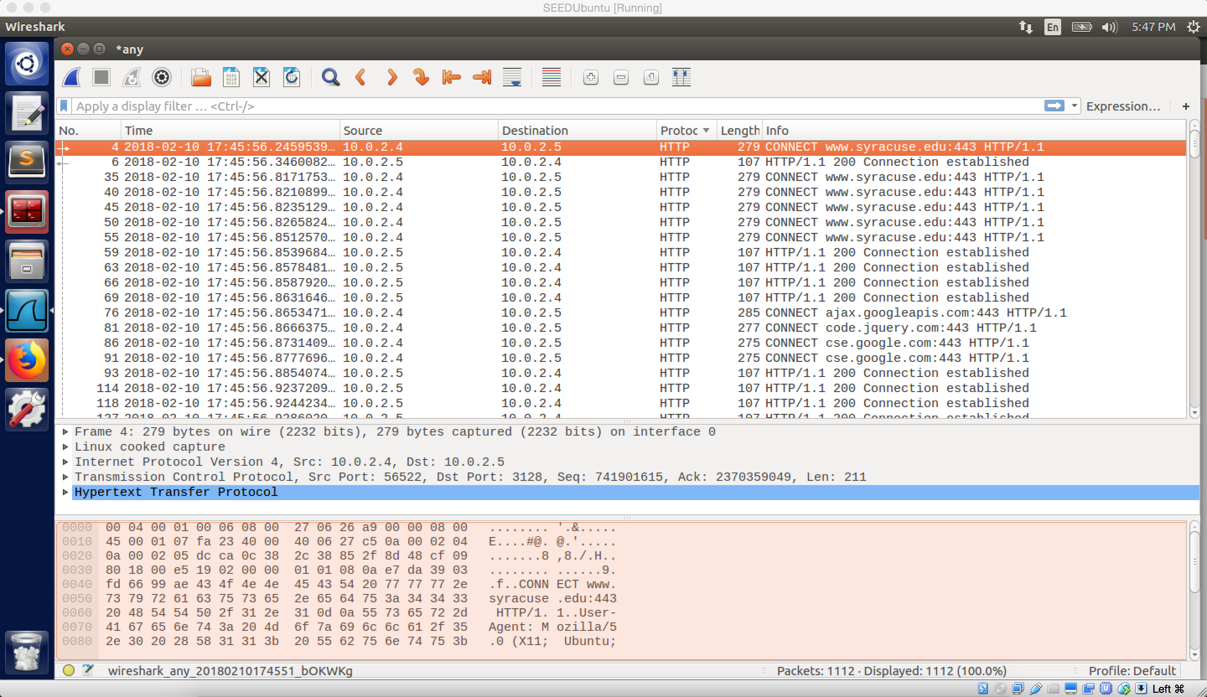

Screenshot 2 on VM A. After I add rule of “http_access allow all” and start squid on VM B, I can access all website from VM A.

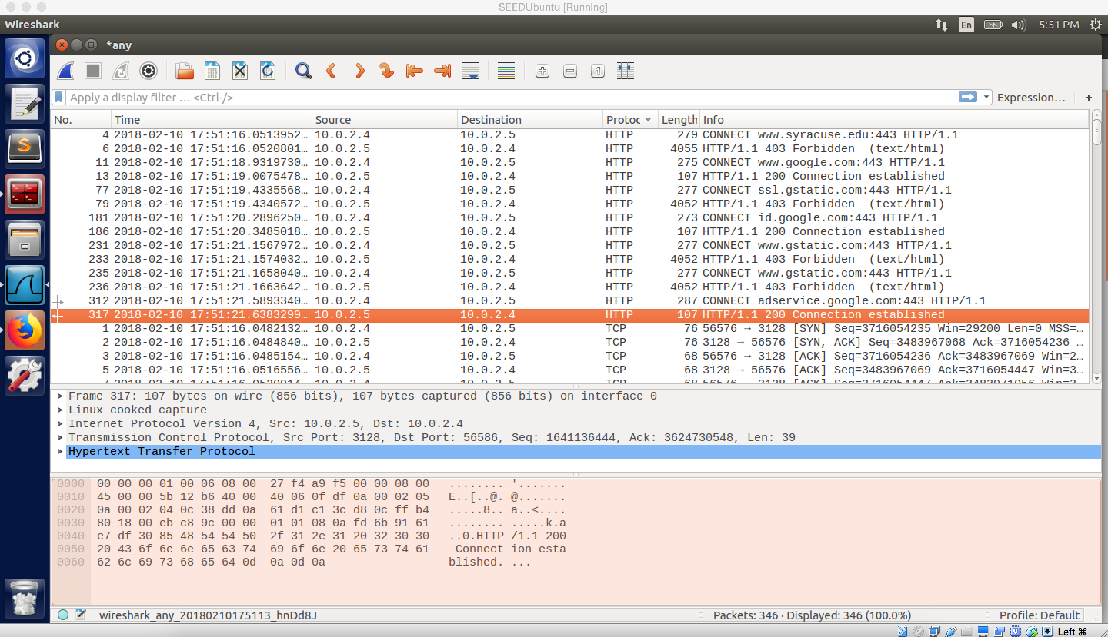

Screenshot 3 on VM A.

**Observation:**

1. After I install squid on VM B and setup browser on VM A, I use the browser to connect SU website; but the connection is refused, the error message shows “The proxy server is refusing connections”. And then I check the Wireshark, it shows I connect to www.syracuse.com with HTTP protocol; but in the next two line, this packet is forbidden. Afterwards, I also try to connect to google.com, but I get same result. This means I cannot connect to this website by browser. (screenshot 1)
2. And then I go to read squid.conf. The http_access rule is used to allow or deny access based on defined access list, and it will allow or deny a message received on http, https, or FTP port. Because we have not yet add any rules in squid.conf, its default value is to deny request. Therefore, all external websites are blocked.
3. After I add “http_access allow all” to the squid.conf, I can use the browser to visit all website now. “http_access allow all”” mean allow http, https and ftp port to receive message. As the Wireshark shows, when we connect to SU website, the connection is established (screenshot 2)
4. After I add “acl GOOGLE dstdomain .google.com; http_access allow GOOGLE” and delete “http_access allow all”, I can only access to google.com. all other websites are locked; the error message is “The proxy server is refusing connections”. The Wireshark shows only the connection to google.com is established, other connections are forbidden (screenshot 3).

**Explanation:**

Web Proxy is an application firewall; it is used to control browser access. When we configure the browser to use http proxy with a particular IP address and port 3128, it actually builds a bridge between host machine and the machine of the particular IP address (in our case, they are VM A and VM B); and the Web Proxy will enforce all packets (transport between our browser and destination) go through the bridge. Meanwhile, Web Proxy can also add rule to the bridge, so it can control access of the bridge. In step 1, because squid deny any request by default, so we cannot use the browser to visit any website, and we can see all HTTP packets are forbidden (screenshot 1). In step 3, after I add rule to squid.config which allows all request, so I can use browser to visit any website; meanwhile we can see HTTP packets shows connection established (between 10.0.2.4 and 10.0.2.5) with port 3128 (screenshot 2). In step 4, after I change the rule which restrict access of any website, except google.com; the only website I can visit is google.com, and other website are blocked. As the screenshot 3 shows, only connection to google.com is established, and other connections are forbidden.

**Task 4.b**

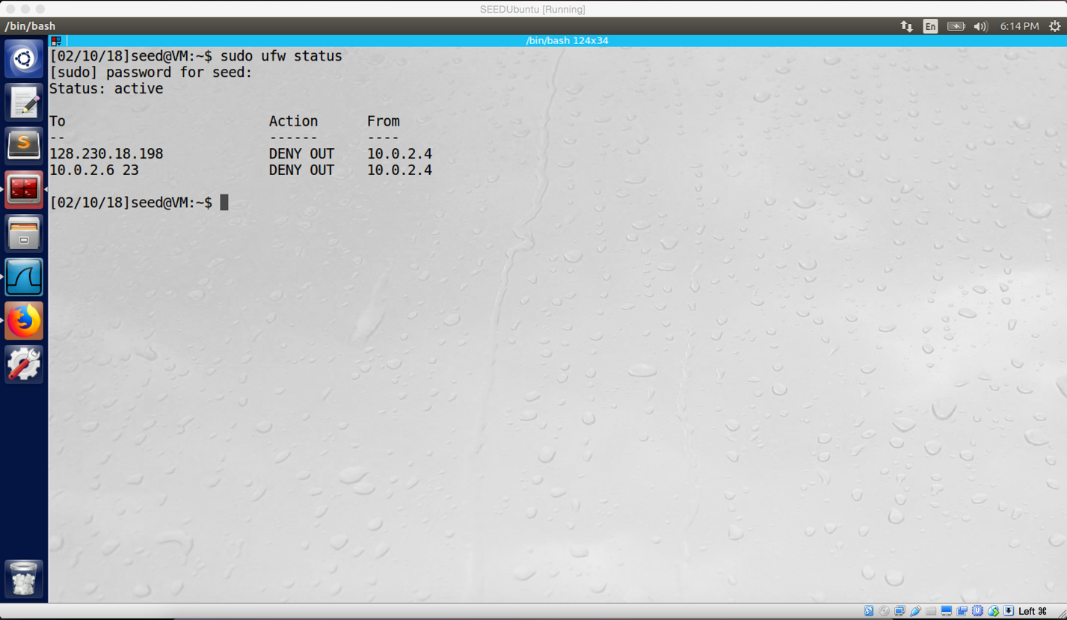

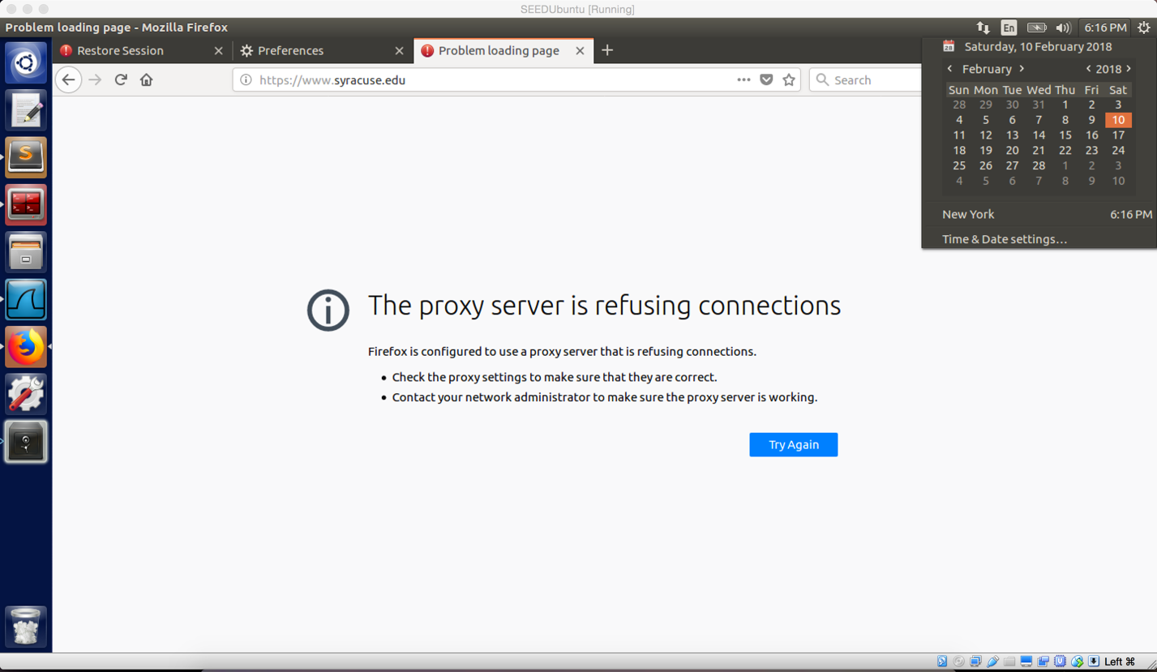

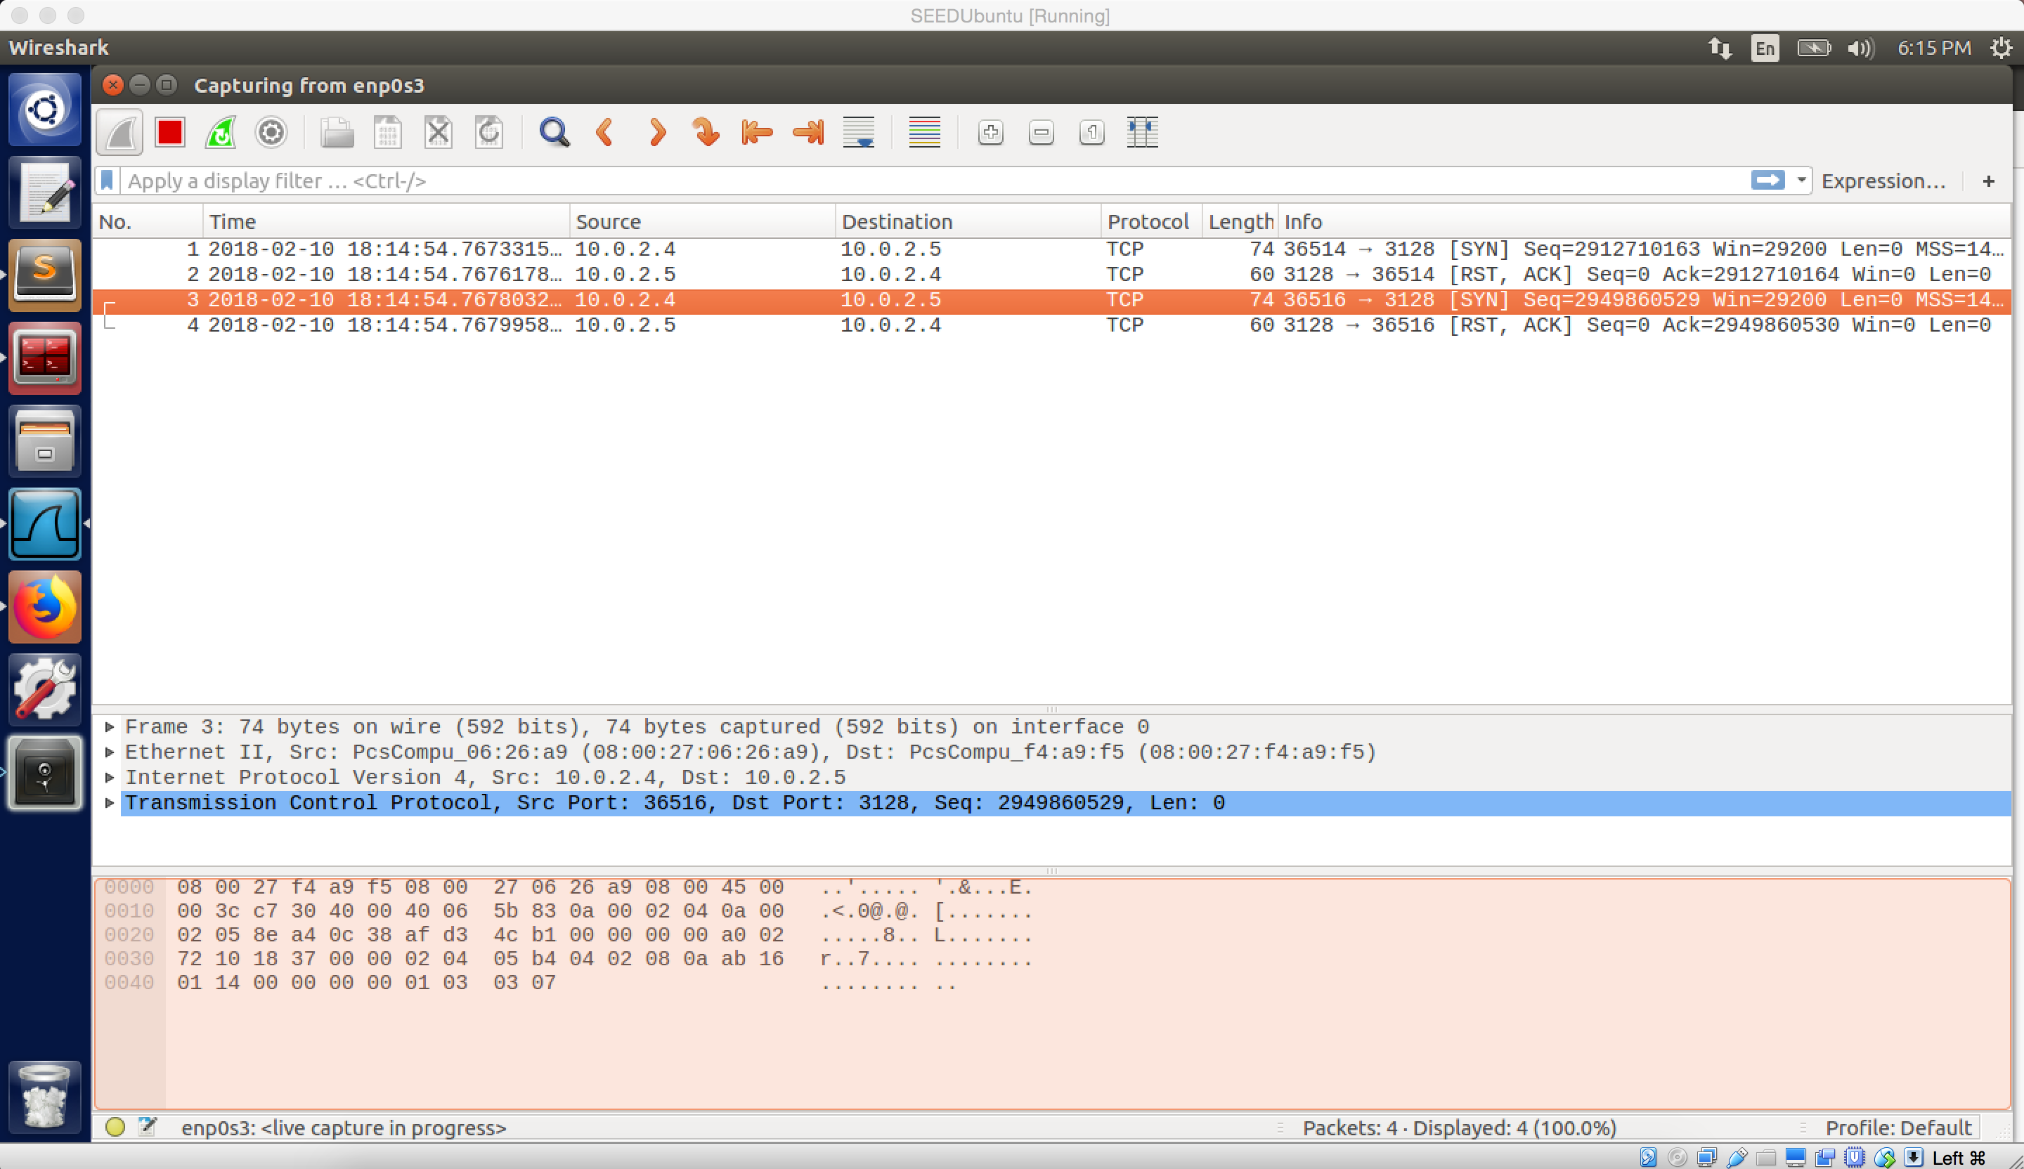

Screenshot 1 on VM A. Enable ufw on VM A and add rule to block SU main website. Cannot connect to SU website.

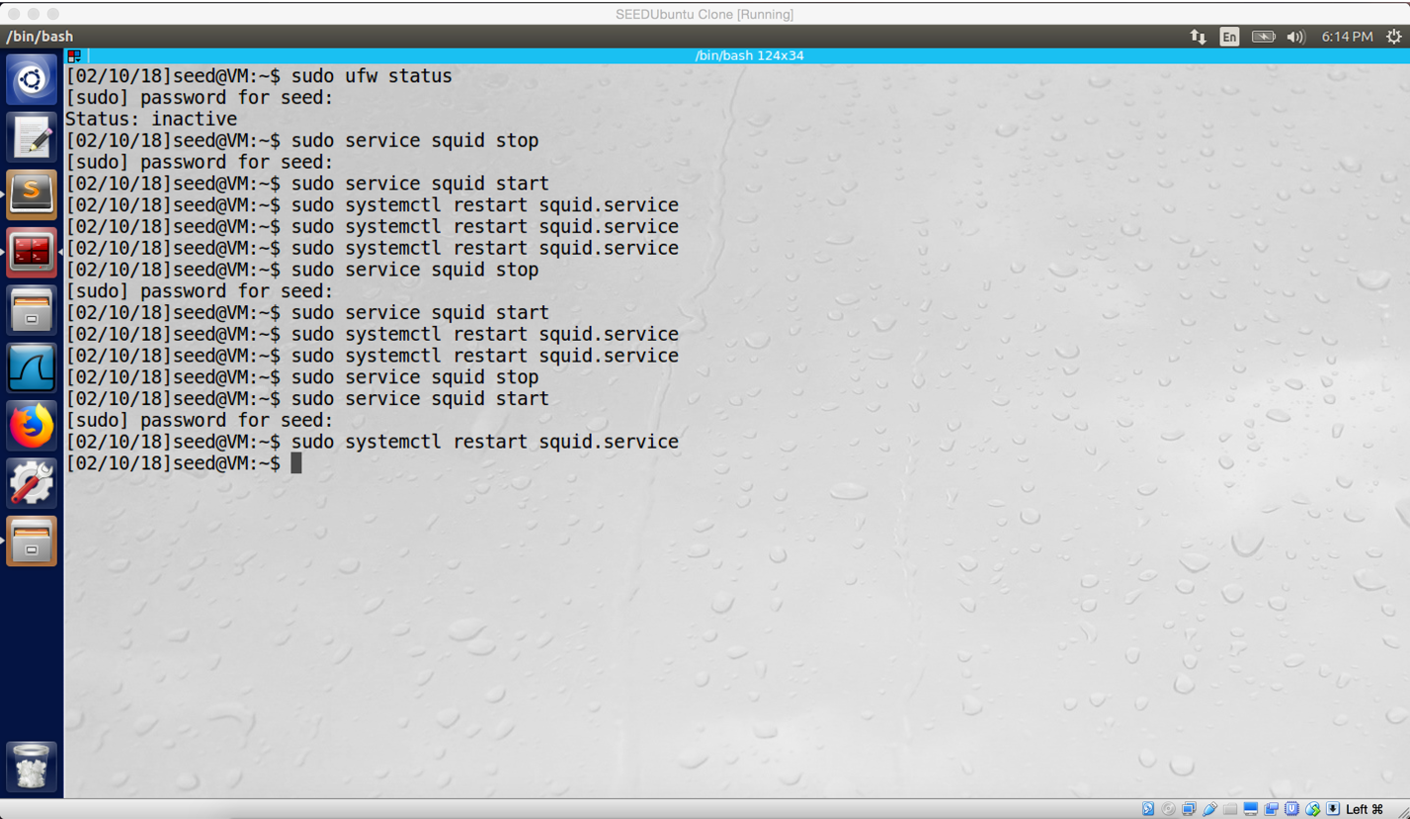

Screenshot 2 on VM B. Update http_access and restart squid on VM B

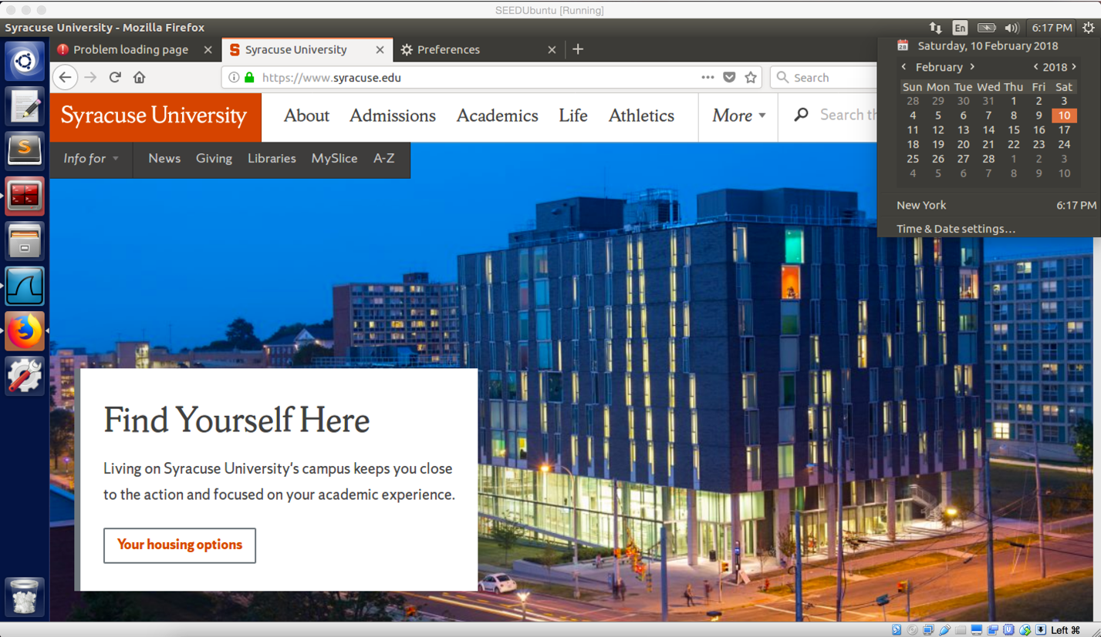

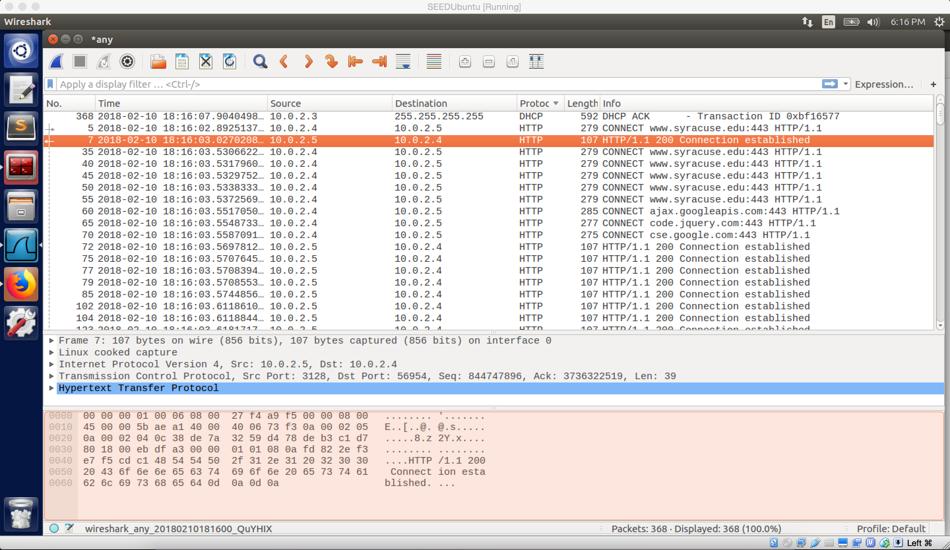

Screenshot 3 on VM A. Successfully bypassing the firewall and connect to SU main website

**Observation:**

First, I enable ufw firewall, and ufw already has rule to block SU website (screenshot 1). Afterwards, on VM B, I updated the squid.conf file, I set to allow all request. Finally, I use the browser to visit SU website successfully (screenshot 3) shows (I didn’t change the browser setting, so HTTP proxy still open).

**Explanation:**

In this task, we use Web Proxy to build a bridge between VM A and VM B. Because ufw does no block communication between VM A and VM B, we can send our packets to VM B by the bridge with port 3128; and then the VM B will forward these packets to SU website. Afterwards, SU website will send packet back in the same path, but reverse order. In the screenshot 3, we can see the connection to SU website is established.

**Question 5:**

Squid use port 3128 as web proxy server port in default. Therefore, after I added rule to ufw to block this port, I cannot use web proxy to evade the firewall. However, if we change port 3128 to the other ports (such as 8080, 6588) in the squid.conf file, then we can use web proxy again.

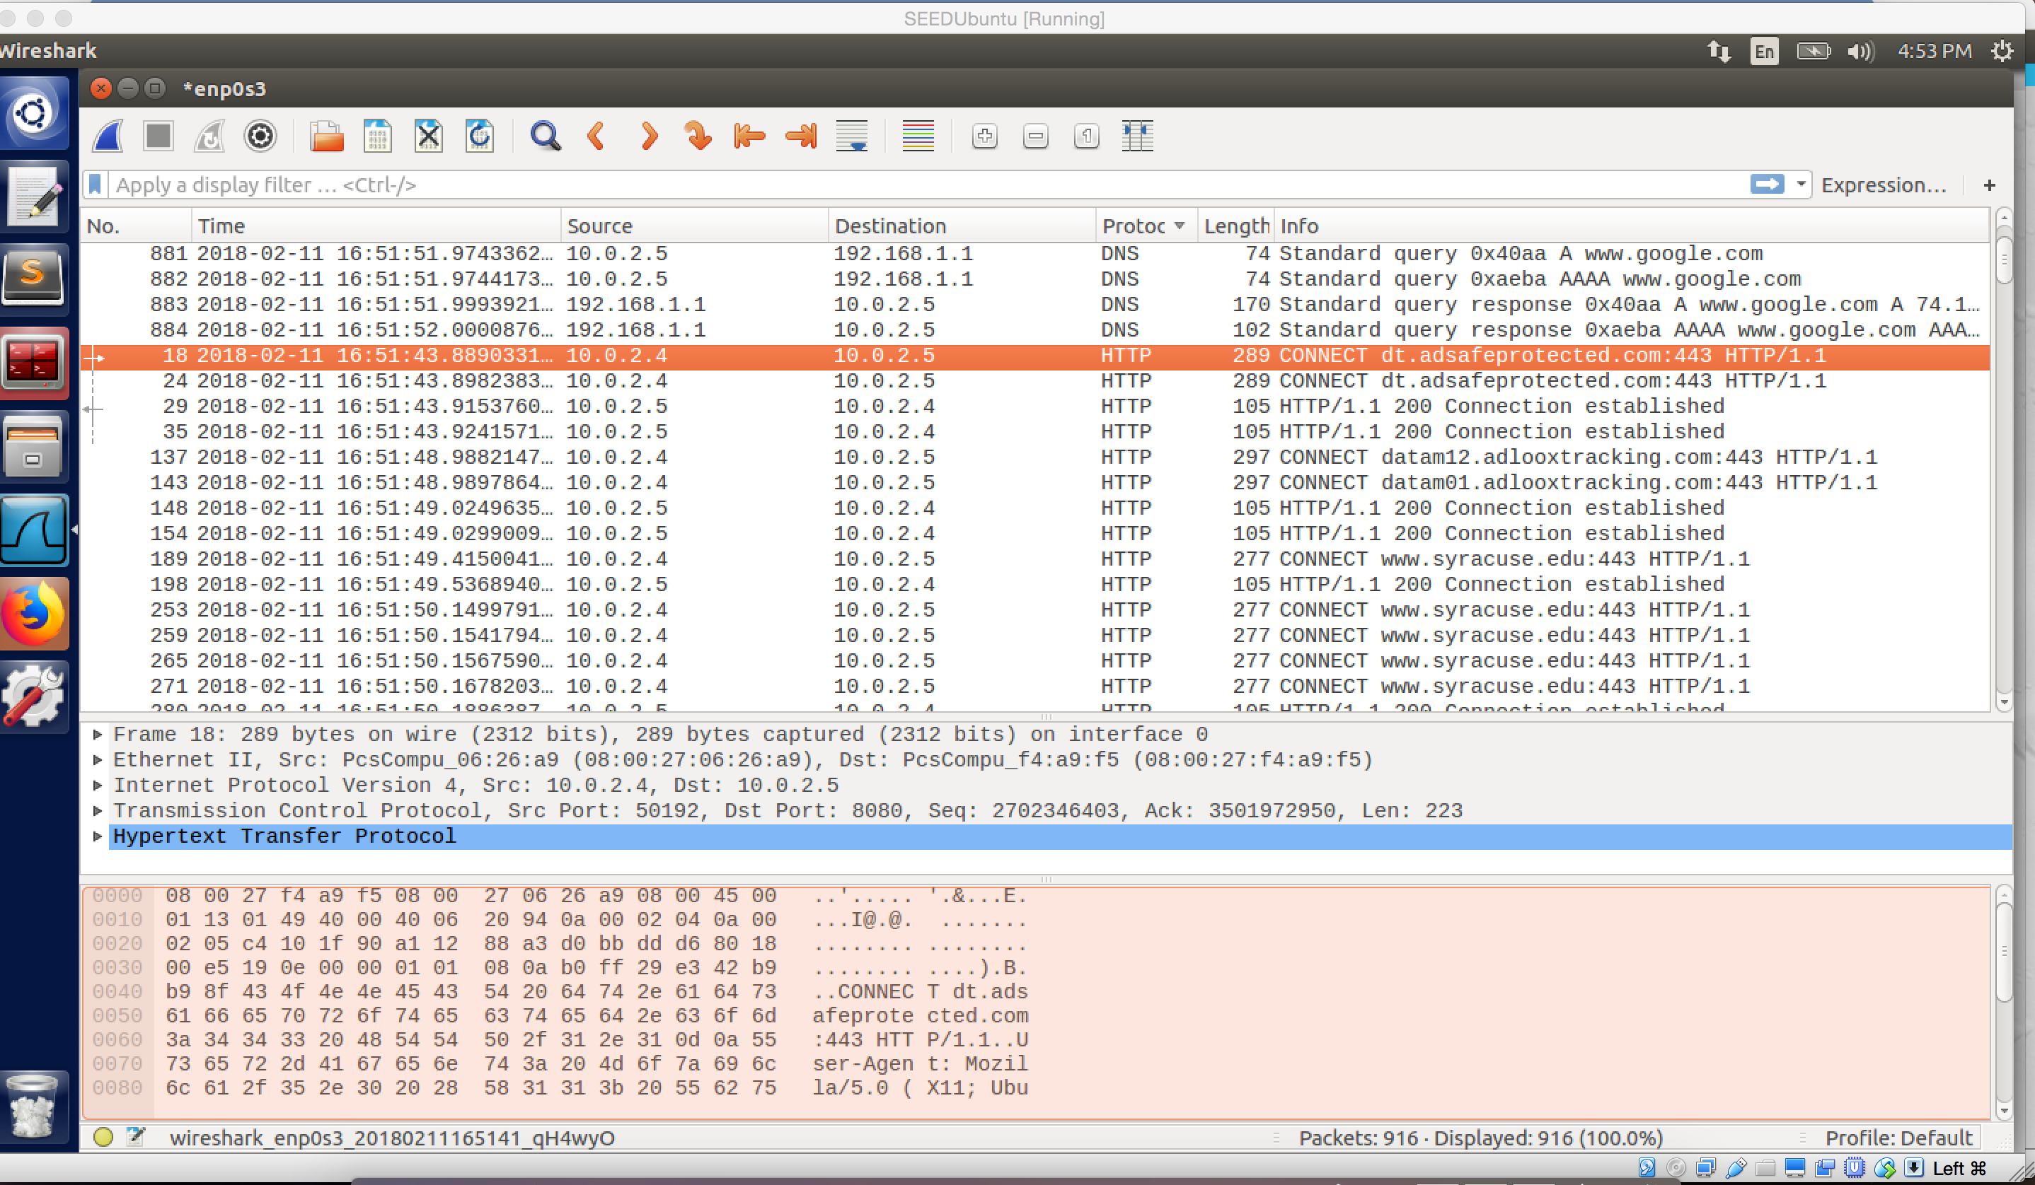

Web proxy works on port 8080

**Task 4.c**

Because squid is HTTP proxy, it does not work on HTTPS. As TA Kailiang’s suggestion, I use www.bbc.com to do this task.

1. For the code, the only thing I changed which is using bbc.com instead of cis.syr.edu

#!/usr/bin/perl -w

use strict;

use warnings;

# Forces a flush after every write or print on the STDOUT

select STDOUT; $| = 1;

# Get the input line by line from the standard input.

# Each line contains an URL and some other information.

while (<>)

{

my @parts = split;

my $url = $parts[0];

#check url is the url we want

#if yes, redirect the user to the "STOP" sign page

if ($url =~ /www\.bbc\.com/) {

# URL Rewriting

print "http://www.yahoo.com\n ";

}

else {

# No Rewriting.

print "\n";

}

}

The above code is used to written URL. In the if statement, when the target URL is www.bbc.com, it will be rewritten to www.yahoo.com. As a result, every time when we visit www.bbc.com, we will be redirected to www.yahoo.com. If we change bbc.com in the if statement to other website, then the new URL will be written by yahoo.com as well.

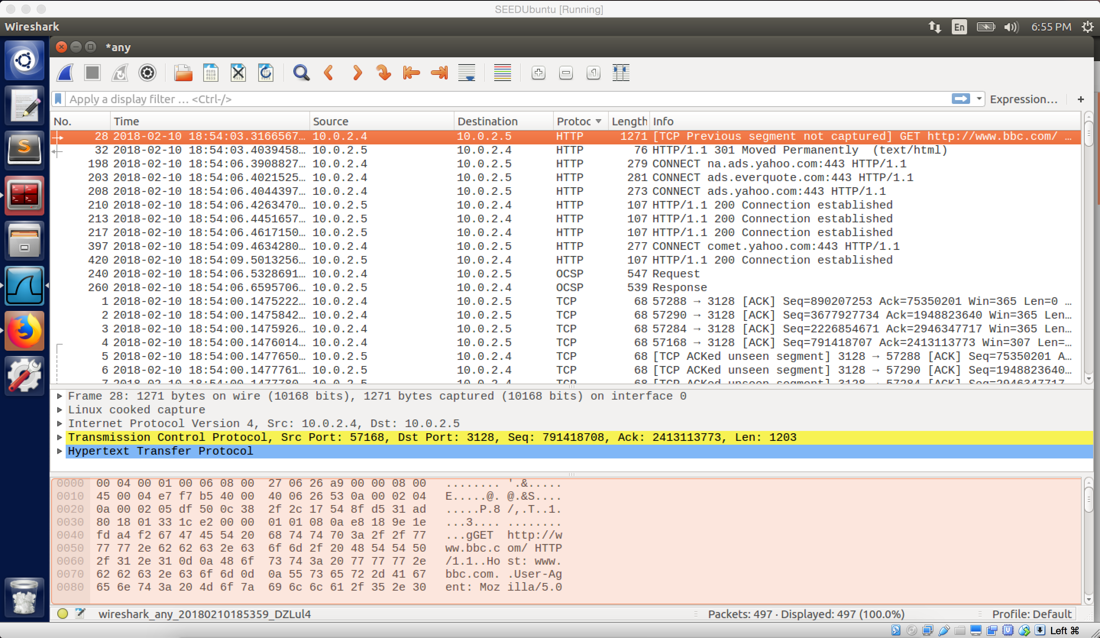

screenshot 1. According to the screenshot of Wireshark, the first HTTP packet contained information of bbc.com, and then it is written to be yahoo.com. Finally, the connection to yahoo.com is established.

1. For the code, I leave all things unchanged, excepting the code inside the if statement. And I changed it to

print "http://upload.wikimedia.org/wikipedia/commons/b/bd/France_road_sign_AB4.svg\n";

which is a page containing big stop sign.

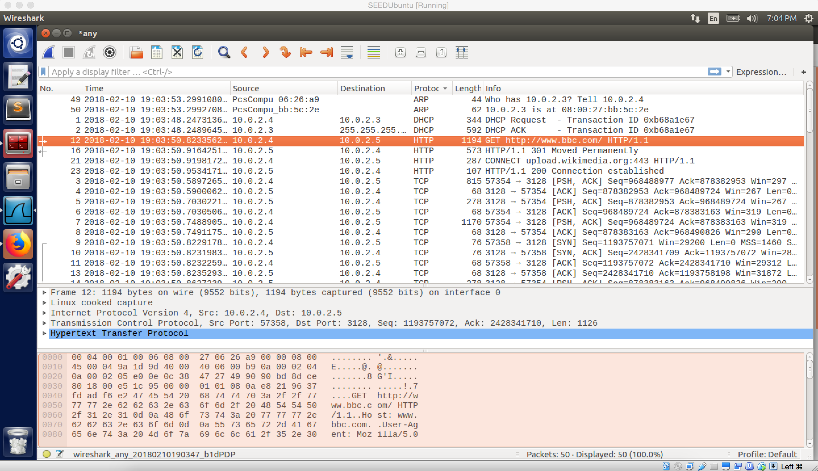

screenshot 2. We can see bbc.com is rewritten again by the new URL, and the new URL redirect us to the following page:

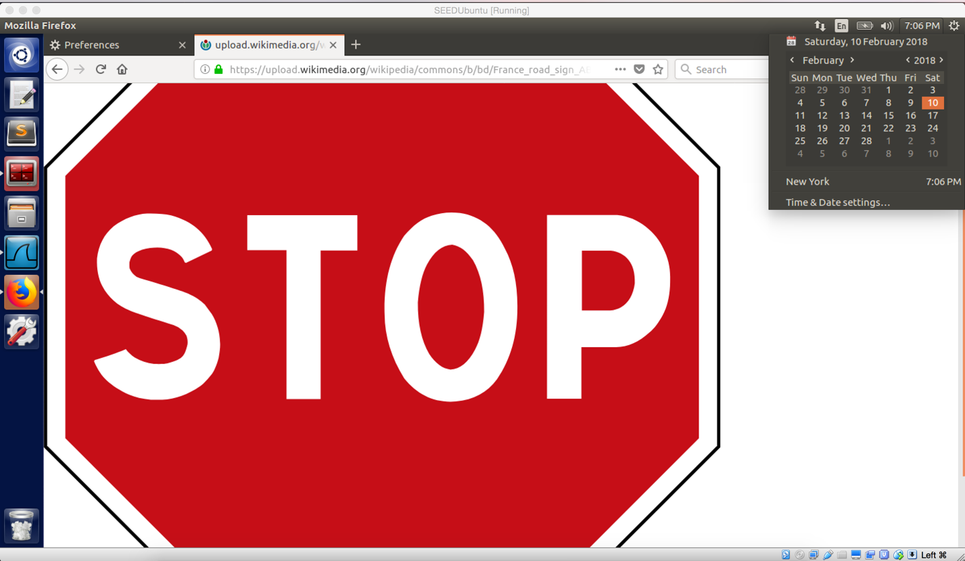

1. For this task, I changed the whole if statement, and my code is following:

#!/usr/bin/perl -w

use strict;

use warnings;

# Forces a flush after every write or print on the STDOUT

select STDOUT; $| = 1;

# Get the input line by line from the standard input.

# Each line contains an URL and some other information.

while (<>)

{

my @parts = split;

my $url = $parts[0];

#if the url with extension of .gif, .jpg, or .png, this means it's an image

#so we just swap this url with my url, and then the image will also be changed to my image

if (($url =~ /(.*\.gif)/i) || ($url =~ /(.*\.jpg)/i) || ($url =~ /(.*\.png)/i))

{

print "http://www.cis.syr.edu/~wedu/seed/img/setup_img.png\n";

}

else {

# No Rewriting.

print "\n";

}

}

As above code shows, whenever URL with extension of .gif, .jpg, or .png, such link will be rewritten to http://www.cis.syr.edu/~wedu/seed/img/setup_img.png which is a link of my image.

Therefore, when we go to bbc.com again, it becomes following:

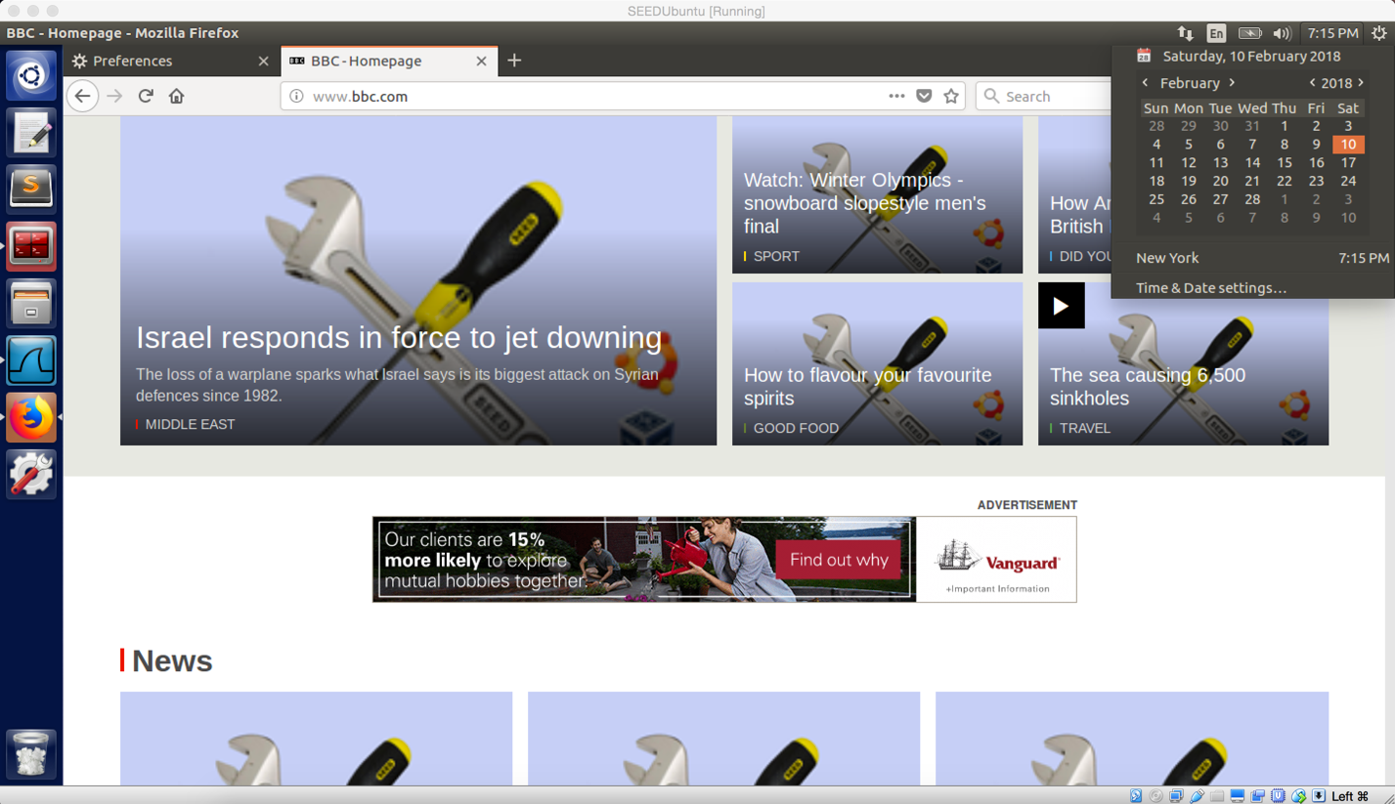

screenshot 3. All images on www.bbc.com are changed to be my image.

**Observation and Explanation:**

1. I first try to understand and use code from myprog.pl. The most important part of the code is if statement part. The if part will compare the current URL with the URL we set, if they are same, then the current URL will be rewritten. In our case for step one, when we visit bbc.com, we will be redirect to yahoo.com (screenshot1).
2. In this step, I changed statement inside if. So every time when we visit bbc.com, we will be redirected to a page will stop sign (screenshot 2).
3. In this step, I changed the whole if statement part. For the if statement, the program, will catch any URL link with extension of .jpg, .png, or gif. These are image file extension. Therefore, the program will catch any image on the website. And then it will rewrite the image to my image. As a result, when we visit bbc.com again, all images are replaced by my image (screenshot 3).

**Question 6:**

Yes. We need to build a tunnel between host machine and another machine, then we can add date into an ICMP packet and send it (by the tunnel) to the other machine by ICMP request. After that machine received packet, it can forward the ICMP packet to a server. When the server received the packet, it can send reply back in the same path with reverse order. This seems not very hard.